From Protocol to Practice: A Bridge to Global Action on Forced Labour
(The Bridge Project)

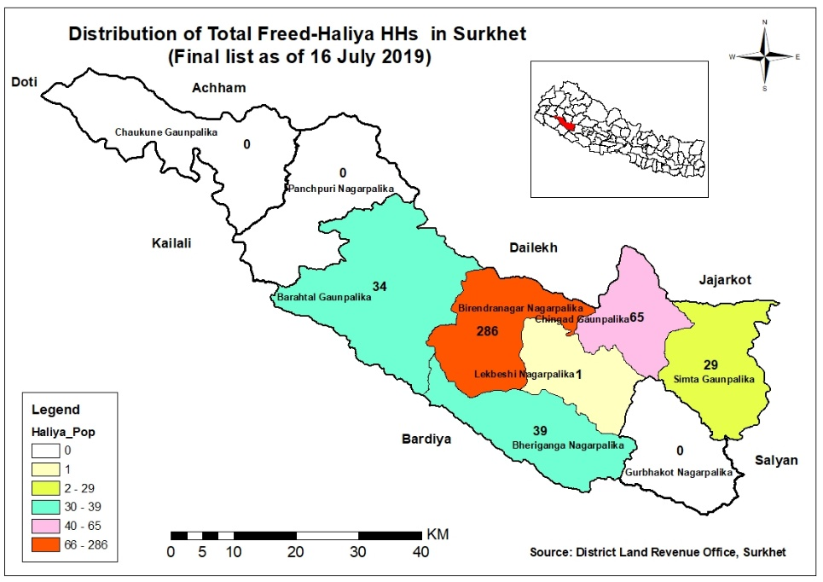

Report on:

Market Analysis and Beneficiary Needs Assessment for a Livelihood Support Program for Freed-Haliyas in Surkhet District

Submitted to:
A Bridge to Global Action on Forced Labor
(The Bridge Project)
International Labour Organization (ILO)

Submitted By:
Purna B. Nepali (PhD)
Mohan Sigh Sunar

August 2019

Table of Contents
Contents
List of Tables and Figures 3
List of tables: 3
List of figures: 3
Acronyms/Abbreviations 4
EXECUTIVE SUMMARY 5
1. INTRODUCTION 8
1.1 Background 8
1.2 Objectives 8
1.3 Methodological Framework 8
1.4 Limitation of the study 9
2. REVIEW OF ILO RELATED CONVENTIONS, INSTRUMENT AND RELATED POLICIES AND LAWS 10
2.1 ILO related conventions and international instruments 10
2.2 Federal/Province Policies and Programmes 11
3. REVIEW OF RECENTLY COMPLETED AND ON-GOING LIVELIHOOD PROGRAMS FOR FREED-HALIYAS 13
3.1 Freed-Haliya targeted rehabilitation programs 13
3.2 Livelihood programs by other development partners: 14
4. GENERAL INFORMATION OF FREED-HAILIYA AND THEIR SOCIO-ECONOMIC ISSUES IN SURKHET DISTRICT 15
4.1 Demography of Surkhet district 15
4.2 Distribution of Freed-Haliya Population in Surkhet 15
4.3 Social diversity and geo-graphic distribution of freed-Haliya in Surkhet 16
4.5 Organizational network of freed-Haliya in Surkhet 16
5. EXISTING LIVELIHOOD SITUATION AND NEEDS OF FREED-HALIYA IN SURKHET 18
5.1. Diversification of livelihood activities and trajectories during last 10 years 18
5.2. Major income/livelihood sources and wage rate at local level 18
5.5 Coping Strategies 19
5.6 Migration for employment 19
5.7 Access to land and housing 19
5.8 Access to natural resources 20
5.9 Access to banking and financial services 20
5.10 Information and access to government's transfer programs and budget 21
5.11 Access to amenities and basic services 21
5.12 Education level of freed-haliya families 21
5.13 Skill training received and utilization 22
5.14 Traditional occupations and potentials 22
5.15 Social mobility of women 24
6. GENERAL INFORMATION ABOUT LABOR MARKET SITUATIONS IN SURKHET 25
6.1 Labour force/working age population in Surkhet 25
6.2 Formal and informal employment by industry in Nepal 25
6.3 Number of establishments and persons engaged by classification in Surkhet 26
6.4 Employment status in Surkhet 27
6.5 Labour migration (in and out-migration) in Surkhet 28
6.6 Major market centers in Surkhet 28
6.8 Social preferences of employers 30
6.9 Previous learning on skill training programs 30
6.10 Cost-effectiveness, suitability, and sustainability analysis of freed-Haliya preferred livelihood options 31
7 CONCLUSION AND RECOMMENDATIONS 34
7.1 Conclusion 34
7.2 Key Recommendation 34
References Cited and Bibliography 37
Annexes 38
Annex-1: List of KII participants 38
Annex-2: List of FGD participants 39
Annex-3: Checklist for FGDs 42
Annex 4: Checklist for interviews (KIIs) 45
Annex 5: Checklist for quantitative information and data collection from freed-Haliya 46
Annex 6. Analysis of data from questionnaire interview 46
Annex 7: Findings of KII with Major Employers and Stakeholders in Surkhet 48
SOME GLIMPSES OF STUDY SITES 49

List of Tables and Figures

List of tables:
Table 1: Demographics of Surkhet 15
Table 2: Freed-Haliya HHs distribution in different locations by caste and ethnicity 16
Table 3: Major Income Sources and skill types by caste/ethnicity 18
Table 4: Migration destinations by caste/ethnicity 19
Table 5: Land ownership status before rehabilitation by caste/ethnicity 20
Table 6: No. of Banks, Financial Institutions and Cooperatives by Rural/Municipalities 20
Table 7: Max. Education level of family members by ID categories 21
Table 8: District Population by 10/10 Years Age Groups in Surkhet 25
Table 9: Formal and informal employment by industry in Nepal 25
Table 10: Number of establishments and persons engaged by classification 26
Table 11: Employment Status in Surkhet 27
Table 12: Market centers by Rural/Municipalities of Surkhet Districts 28
Table 13: Key sectors and subsectors for labour market in Surkhet 29
Table 14: Per Person Training Cost and Possibility of Return by Trades 31

List of figures:
Figure-1: Domains of women's movement 24
Figure 2 In- and Out-Migration in Surkhet (Census 2011) 28

Acronyms/Abbreviations

CBS Central Bureau of Statics
CCI Chamber of Commerce & Industries
CTEVT Council for Technical Education and Vocational Training
DCSIO District Cottage and Small Industry Office
DMHS District Mukta Haliya Samaj
FGD Focal Group Discussion
FNCCI Federation of Nepalese Chamber of Commerce & Industry
GIZ German Technical Cooperation
GoN Government of Nepal
HDI Human Development Index
ILO International Labour Organization
INGO International Non-Government Organization
KII Key Informant In-depth Interview
NGO Non-Government Organization
NLFS National Labour Force Survey
OJT On-the Job Training
SIC Section of Industrial Classification
STEP Skills Training and Technical Education for Employment Project
TVET Technical Vocational Education and Training
UCEP Underprivileged Children’s Education Program

EXECUTIVE SUMMARY
This study is a market analysis and beneficiary needs assessment for a livelihood support program for freed-Haliyas in the Surkhet district, in context of the ILO’s ‘From Protocol to Practice: A Bridge to Global Action on Forced Labor’ (The Bridge Project). The main objective of this study was to collect and compile information on completed and on-going livelihood programs for freed-Haliya. In addition, the study sought to analyse the needs of the Freed-Haliyas and the labor market situation in Surkhet district, in order to recommend cost effective and sustainable livelihood options for Hailyas.
The study mainly used mixed methods and approaches. The primary data was mainly collected through FGDs and KIIs. The data was collected from 42 participants of FGDs through interviews which were analyzed. Data from secondary sources was also analyzed to draw findings. A district level consultation workshop and official visit with governmental officers from different ministries was also undertaken, to further identify, understand and confirm some of the findings and issues raised during the field visit.
Key findings:
- According to the data records of the District Land Revenue Office Surkhet, 454 freed-Haliyas have finally been verified and entitled to receive the government rehabilitation package. Of the total 454 freed-Haliya population in Surkhet, 50.2 percent were from the Dalit community, followed by the Tharu community (41.4 %); while there was a lower proportion from the Hill Janajati and Khas Arya communities at 6.6% and 1.8% respectively.
- The population of the verified freed-Haliya is spread across 18 wards of six rural/municipalities of Surkhet. Almost 63% (i.e. 286) of the freed-Haliya live in Birendranagar Municipality where the Tharu freed-Haliyas' number was dominant.
- There were no targeted programs for the freed Haliya community in Surkhet except for the governmental rehabilitation program which provided support only for purchasing land, house construction and repair as per the category of freed-Haliya.
- Recently, the Ministry of Social Development (MoSD) of Karnali Province formulated a Labour and Employment Promotion Policy 2018, which includes the design a specific labour employment program for disadvantaged groups, including the Freed Haliyas. The MoSD was welcoming for collaboration. The Agriculture Sector Development program implemented in Karnali Province also provides an opportunity for freed Haliya, if they obtain access to such programs.
- In the communities, there were a number of grievances of unverified freed-Haliyas. The issue of improper categorization of freed-Halliya was a major issue among the stakeholders.
- The freed-Haliya families in study sites were found to be living near to the rivers and forests (jungle), but they had very limited access to natural resources.
- The main livelihood option for the freed-Haliya families was labour works. The adults who were Haliya in the past, were mainly involved in labour works. There had been no significant change in their livelihood activities over the last 10 years.
- In order to cope with the livelihood shocks, the freed-Haliya families were engaged in more than one livelihood activity. They were also earning their livelihoods from agriculture, traditional occupations and migration to India and gulf countries.
- The quantitative data collected during the FGDs showed a high seasonal migration trend among freed-Haliya families. For instance, out of 42 respondents asked about the migration, at least one family member of 32 respondents (i.e. 76%), had migrated for employment. The main migration destination was to India. The seasonal migration trend was very high among Dalit community, which was just opposite in Tharu community who were working in the villages. This might be due to Tharu community having access to land as compared to the Dalit communities.
- Access to land was very limited in Haliya community study sites. For instance, only 4 respondents (i.e. 10%) out of the 42 respondents asked during FGDs, had their own land before the rehabilitation and the rest of the 38 had received governmental support for land access. Some of them have been holding up to nine Ropani of land. However, they are just holding the land, but they do not possess a land certificate. This status does not ensure their land ownership rights.
- In all FGD locations, the freed-Haiya family members were involved in either saving-credit groups or cooperatives. The freed-Haliyas have been saving Rs.50 to Rs. 200 every month in their respective groups and cooperatives.
- The freed-Haliya family members were aware of social security schemes of the government including old-aged pensions. However, they had no information about the local government budget process.
- The highest education level of the freed-Haliya families was grade 12. The most educated were the respondents aged 18 to 35 years. The adults who worked as Haliya were hardly literate. The literacy and numeracy skills of the participants aged 18 to 35 years is sufficient however, for the level-1 training. The English understanding of the participants seems poor. In comparison to the sons, the daughters and daughter-in-laws had a higher level of education in the freed-Haliya families.
- The lack of amenities in newly resettled areas was also an issue for the freed-Haliya families. Their houses were built in small areas of land. There was also a problem of income generating sources in the new areas. For instance, the houses constructed at Bhimdana of Gurbhakot Municipality for the freed-Haliya of Bherignaga were far from their original residences and were not in use due to the distance
- The wage rate differed between rural-urban locations, both for skilled and unskilled workers, which ranged from Rs.500 to Rs.1200 per day and the total working days in a month ranged from 17 days to 22 days.
- The five main sectors (Engineering, Agriculture, Miscellaneous, Tourism/ Hospitality and Handicrafts) had a high demand forskilled labour in Surkhet. The freed-Haliya expressed their need and interest in skills training in the 10 sub-sectors. The consultation with employers and stakeholders showed that there was demand for skilled labour in 19 sub-sectors of the five main sectors.
- A significant number of adult masons in freed-Haliya communities that were working also sought training opportunities so that they would be able to receive a certification of their skills. Due to the lack of certification, they have had to receive a lower rate and/or receive less work.
- The right participant selection, model of training and timing of training period impacts the effectiveness of the training.
Key recommendations for the planned project:
Aligning with the project objectives and targets, the study has also assessed the cost-effectiveness, and sustainability aspects, and prioritized the seven sub-sectors of livelihoods which seem highly relevant for the target groups. The recommended priority are: (i) Mason, (ii) Off-season vegetable producer, (iii) Tailoring, (iv) House painter, (v) auto mechanic, (vi) Village Animal Health Worker, and (vii) Plumber. The project can select up to five or less recommended sub-sectors for conducting skills training.
here should be a clear and comprehensive process and criteria for the participant's selection. The minimum qualification, willingness and determination of participants as wells as their basic knowledge about the backward and forward markets and viability of self-employment are necessary conditions for participant selection. The gender and equity aspects should be sufficient conditions for the selection criteria. An adequate planned time should be invested for participant's selection.
- Gender discrimination and stereotyping have impacted the social mobility and productive roles of women in the community. In order to promote gender equality, the participant's selection processes encourage and facilitate women candidates to select non-traditional trades.
- The project should design mixed model of training both residential and nonresidential. Due to the scattered settlements of the beneficiaries, it would be difficult to find 20-40 freed-Haliya participants in all locations. The participants from remote areas can benefit from a residential training. The participants from nearby Birendranagar who are also unable to stay in the training venue can participate the non-residential training. Moreover, if the participants are selected from different locations for a particular trades, it will decrease competition when they start their enterprises or self-employment in their locations/villages/local markets. To reduce the cost of the residential training, the project can manage a home-stay type of accommodation for the participants.
- The project should consider the possible negative impact of the participant’s family member's engagement in seasonal agricultural work. The period from May to November is a busy period when there are different agricultural tasks, harvesting and work to do also for the different festivals. The suitable time for skill training will be between the months of December to April.
- The project can provide skill testing opportunity to adult freed-Haliya who already possess a good knowledge of the trade, but are not yet certified. The adult freed-Haliya who have been earning their livelihood from daily wage works, and whose offspring are not at working age, seem much vulnerable due to lack of certified skill. The skill certification will reduce their vulnerability. This will also contribute to increase the income of freed-Haliya families at a minimum cost. The project can include them while organizing skill tests to the core targeted trainees.
- Due to the destitute situation of the freed-Haliya, skill enhancement alone does not ensure self/employment and entrepreneurship development. Therefore, post-training support and skill certification should be integrated. The enterprise start up support, job placement support, linkage to markets and financial access and soft skills for business development are vital to ensure a maximum increase in participant's income after the training.
- The Labour and Employment Promotion Policy-2018 of Karnali province would be the advocacy tool for freed-Haliya. The welcoming attitude of the MoSD in Karnali, will be an opportunity to cooperate particularly in the areas of advocacy and livelihood promotion programs. The project should maintain effective coordination with all the government and private sector actors from very beginning. It will be supportive for the sustainability of the project. The advocacy initiative looks crucial to leverage local resources.

INTRODUCTION

Background
Haliya, literally meaning ‘one who ploughs’, are the group of agricultural bonded labors who work on the fields of others to earn their livelihood. It is practiced mainly in the hilly regions of the mid and far-western region and is closely associated with the system of debt bondage, often seen in caste-based communities where Haliya, often poor and landless, work for their landlords to pay off the principal and interests their ancestors borrowed. Since they are not paid in cash, they remain unable to clear the debt and the debt bondage transfers to the next generation, thereby making the Haliya community more vulnerable and more backwards. This is a major form of human exploitation. In recent years, many NGO’s and INGO’s are working to raise awareness and reduce the exploitation of the Haliyas. Due to the change in the political situation of the country and the issues of social security and equity being promoted, the government identified the Haliya community as a backward and vulnerable community and attempted to overturn the system by freeing Haliya from the ancestral bondage. In practice, the government designed and implemented rehabilitation program for Freed-Haliyas and collaborates and cooperates with different NGOs and INGOs.
The Bridge project works globally to provide specific guidance on effective measures to be taken to eliminate all forms of bonded and forced labor, in the areas of prevention, protection and access to justice. The project aims to eliminate traditional and state-imposed forced labour systems and to significantly reduce contemporary forms of forced labour.

Objectives
In such context, this study was carried out as a market analysis and beneficiary needs assessment for a livelihood support programs for freed-Haliyas in Surkhet district in context to Bridge Project titled From Protocol to Practice: A Bridge to Global Action on Forced Labor (The Bridge Project). The project has been managed by ILO in two districts of Nepal (i.e. Bajura and Kanachanpur) through national partner organizations since September 2015. Now, the ILO has planned to expand the project activities to Surkhet district and work with at least 100 freed-Haliya families.
The specific objective of this study was to collect and compile information on the following aspects in Surkhet district:
- Mapping of recently completed and on-going livelihood programs for freed-Haliyas with the support of all development partners;
- Generating the general information about the labour market situation and the needs of the target group (freed-Haliya);
- Recommending the cost-effective, target group (freed-Haliya)-focused, sustainable livelihood options/programs for the BRIDGE Project.

Methodological Framework
The study has mainly used mixed qualitative methods and approaches. However, quantitative data from secondary sources has also been analyzed to draw the findings. The qualitative data was mainly collected through focus group discussions (FGDs) and key informant interviews (KIIs). A total of six FGDs (one with government and NGO stakeholders, and five with rights holder freed-Haliya families) were conducted during seven days of field works. The sites for FGDs were selected to ensure representation of social and geographic diversity, rural-urban context and gender aspects of the participants. Therefore, two FGDs were done in Tharu populated areas, two in Dalit populated areas and one in a mixed Tharu and Dalit area. In order to understand the gender aspects, a special FGD was conducted with a group of only women. The KII at field level was done with 23 persons representing employers' organizations, Dalit entrepreneurs, NGO activists and freed-Haliya leaders (Please Annex-1). Moreover, in order to quantify the responses and do quantitative analysis, a total of 42 participants of FGDs in three locations of three rural/municipalities were asked about their category, family size, family members aged 18 to 35 years, education, land holding size, skills, employment status, wage rate, migration and the destinations.
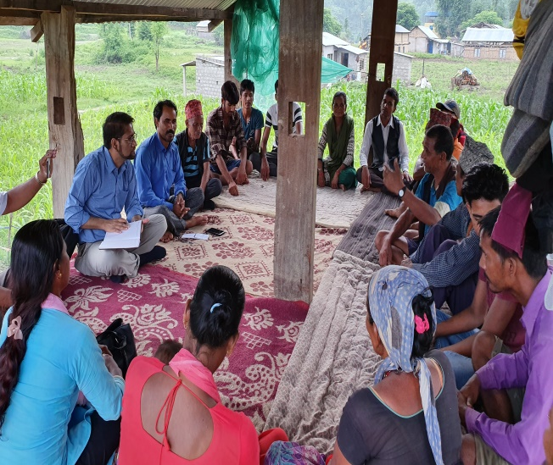  Picture 1 FGD at Thapadera of Barahatal-2 | 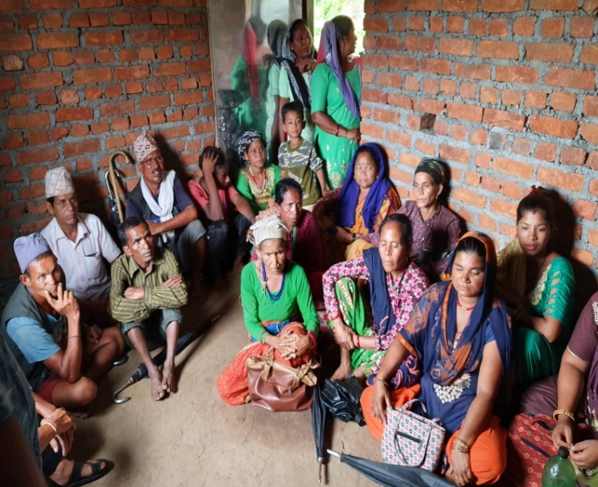  Picture 2 FGD at Bhimpurdanda, Gurbakot
The technical quality assurance was done through the discussion, sharing, and learning to the team members and enumerators on data collection tools and techniques, FGDs and KII conducting methods in Surkhet. Pretesting of questionnaire and assurance of the checklist for FGD and KII was done through expert consultation so that the consistency and logical order of study is maintained and quality is assured.
The outcomes from FGDs and KIIs were triangulated with the mini questionnaire survey done in 42 Haliya households for consistency check and validating the data for analysis.
The reliability and validity of the data was assured by reviewing the literature and consultation with experts. The questionnaire and guidelines were finalized and research control mechanism was developed for data validity assurance. Similarly the triangulation of data was also carried out for the validity of data during the analysis of survey information.
Moreover, the participants were selected on the basis concentration of Haliya and Dalit Community and representative strata made on the basis of caste, gender and age group (referring to government data and records of District Land Revenue Office, Table 2).

Limitations of the study
The study has its limitation on following aspects:
- It has as time limitation as it was completed in a short time.
- The study was conducted during July when the seasonal agricultural work was quite high, thus limiting the presence of participants.
- As it has a low or limited coverage and covers only Surkhet district, findings cannot be generalized at the province or national level
- Qualitative methods were mostly used for the study, so it may not be free from biasness and prejudice.
Despite these limitations, special attention has been taken to minimize error by proper validation, quality control and detailed analysis on the subject matter.

REVIEW OF ILO RELATED CONVENTIONS, INSTRUMENTS AND RELATED POLICIES AND LAWS

ILO related conventions and international instruments
There seems to have been little evidence of a reduction in the incidence of forced labor and modern slavery even in the present context. The worldwide statistics shows that the devastating record of human right abuses. ILO & Walk Free Foundation (2017) records about 40 million people in the modern slavery of which about 25 million are in forced labor.
ILO has set the International labor standards and the legal instruments , which define the basic principles and rights at work. They are either Conventions/Protocols which are legally binding international treaties or recommendations which act as non-bonding guidance. These conventions and recommendations overall foresee the status of bonded labor, child labor and modern slavery and work to technically assist the nations for their effective abolition and elimination of discrimination in respect of employment and occupation. In this regard, ILO have declared eight fundamental conventions:
- Freedom of Association and Protection of the Right to Organize Convention (No. 87), which maintains that freedom of expression and association are essential for sustained progress and improved working conditions. In addition, it reserves the right for workers to join organizations of own interest without previous authorization.
- Right to Organize and Collective Bargaining Convention (No. 98); which ensures the adequate protection of workers against anti-union discrimination in respect of their employment.
- Forced labor Convention (No. 29), which aims to suppress the use of forced or compulsory labour in all its forms within the shortest possible period.
- Abolition of Forced labor Convention (No. 105), which undertakes to suppress and not to make use of any form of forced or compulsory labour-- as a means of political coercion or education or as a punishment for holding or expressing political views or views ideologically opposed to the established political, social or economic system; as a method of mobilising and using labour for purposes of economic development; as a means of labour discipline; as a punishment for having participated in strikes; as a means of racial, social, national or religious discrimination.
- Minimum age Convention (No. 138), which is to ensure the effective abolition of child labour and to raise progressively the minimum age for admission to employment or work to a level consistent with the fullest physical and mental development of young persons.
- Worst Forms of Child labor Convention (No. 182), to take immediate and effective measures to secure the prohibition and elimination of the worst forms of child labour as a matter of urgency.
- Equal Remuneration Convention (No. 100), for determining rates of remuneration, promote and, in so far as is consistent with such methods, ensure the application to all workers of the principle of equal remuneration for men and women workers for work of equal value.
- Discrimination Convention (No. 111), to declare and pursue a national policy designed to promote, by methods appropriate to national conditions and practice, equality of opportunity and treatment in respect of employment and occupation, with a view to eliminating any discrimination in respect thereof.
In addition to these conventions of the ILO, Alliance 8.7 of Sustainable Development Goals (SDGs), i.e. Joining forces globally to end forced labour, modern slavery, human trafficking and child labour also prioritizes action against these forms of labor through national strategies and policies with a deadline to end forced labour. It provides a platform for partners to come together to share information on promising practices, lessons learnt and demonstrate progress on the abolition of all forms of forced and bonded labor all around the world. For this, Alliance 8.7 will collaborate with all stakeholders for coherence in policy and action and act as one with a targeted objective. The Alliance will also bring together the relevant organizations to generate data and research on status and improve forced labor measures. Acting as an advocacy and information sharing platform, it seeks to foster regional and country collaboration to advance knowledge and action in the light of the targeted objective of abolish forced labour (including the abolishment of bonded labor).
Of these conventions and instruments, four conventions of ILO and the Alliance 8.7 are directly related to the abolition of the bonded labour system of Haliyas in Nepal, which a severe form is of bonded /forced labor in western Nepal. The Government of Nepal ratified the Convention on Forced labor in 2002 and later in 2007, the convention on Abolition of forced labor was ratified. Different governmental, national and international organizations have been recently working under these conventions and instruments to abolish and improve conditions of Haliyas in Nepal.

Federal/Province Policies and Programmes
The provisions against the practice of forced labor was included in 1964 Muluki Ain, prohibiting any forms of bonded without one’s consent and remuneration or wages of the labor are to be fixed by mutual consent or as per the usual social practices or rates. Section 3 stipulates three to ten years of imprisonment against the violator and authorizes courts to order compensation of a reasonable amount of money. It also provides a penalty for accomplices, which could be as much as half of the penalty incurred by the principal violator.
However, there were no specific interventions regarding the elimination of these forms of labor until the restoration of democracy in 1990 and after a decade long campaign to relinquish such practices, the government finally acknowledged the form of bonded labor existing in the country and made an initiative to end these forms of labor. The Nepal labor act was promulgated in 1992 laying down the legal framework and basics for rules, regulation and guidance for workers. In 1999, the National labor policy was made to deal with other policies and programs on different labor issues. The Labor Prohibition Act was promulgated in 2002 in Nepal, the same year that Nepal ratified the ILO convention on Forced labor. This act was enacted so as to have a legal policy for freed labors/Kamaiyas and legally freed all Kamaiyas from any forms of forced labor. Keeping Kamaiya workers was against the law, all their loans were cleared too and the agreement relating to bonded labor was cancelled soon after the law was established. While the single aim of the law was to eliminate the bonded labor system, its implementation has been weak and does not sufficiently address the socio-economic causes of bonded labour systems and practices. It has an unclear definition of bonded labor itself. Similarly, the Labor employment Policy also got promulgated in 2005 which further created opportunities for all workers as a way to sustain their livelihood through decent employment opportunities which was the main objective of the policy.
After Federalism became institutionalized, the issues of freeing bonded laborers came to the limelight in political issues and different political parties had mentioned it in their agenda. Different policies are promulgated and implemented for the same purpose. For instance, several policies including Federal Policies, such as the Foreign Employment Policy (2012), National Youth Policy (2010), are promulgated and Labor Squatter commission and other commissions are working to rehabilitate former bonded labourers. The constitution of Nepal 2015 has made provision (under the state policy) to provide land for housing, agricultural land for employment for freed Haliya. The 14th periodic plan has prioritized promulgating a new policy to complete the task of freed Haliya rehabilitation for which the Supreme Court (SC) had also directed the government to introduce a policy and law for the rehabilitation of freed Haliyas. In 2010, a freed Haliya system (prohibition) Bill was presented setting out the rights of freed Haliya, and establishing a rehabilitation fund, a case litigation and appeal process, and provision for punishment and the bill was finally passed as law in 2017 as an amendment to the Labour Act. The government issued the “Freed Haliya rehabilitation and monitoring guidelines” in May 2011, which mandated an update on the information of freed Haliya, their identification and the distribution of identification cards to them within six months of their being identified. A Census Collecting Team (CCT) was formed to collect data of freed Haliya due to which both the rehabilitation and identification process could have a definite shape. Freed haliyas were identified and classified into 4 classes; (i) those who have neither a house nor land (A), those who have a house but no land (B), those who have land but no house (C), and those who have both a house and land (D). Recently, the Ministry of Social Development (MoSD) of Karnali Province has formulated Labour and Employment Promotion Policy-2018. This policy has given a future scope to design a special program for employment promotion of the disadvantage groups, including freed-Haliyas.
Also, to support to address the issues of freed Haliya, some organizations such as LWF Nepal, CARE Nepal, ILO, RDN, CSRC, NNDSWO have implemented a few small scale projects in in other districts of Far Western and Mid-Western Region of Nepal. In this regard, these organisations are implementing various projects to assist freed Haliya communities to achieve full rehabilitation from slavery and labour exploitation. ILO with financial support from the US Department of Labor is providing support to freed-Haliyas for their livelihood through skill training and employment. NNDSWO, in support of Anti-Slavery International (ASI), is implementing a project to facilitate empowerment of freed-Haliya Community (HC). It aims to break the cycle of slavery and labour exploitation through ensuring participation and representation of the HC, particularly women, in THE the rehabilitation process; support HC children for education through provision of tuition class in order to re-enrol children and assist performance at school; and improving HC employment, livelihoods, and income security through provision of vocational and skill development training to older freed- Haliya children and young adults.
Hence, the learning and best practices from these organisations from federal, provincial, district and local levels should be taken into consideration for planned project interventions.

REVIEW OF RECENTLY COMPLETED AND ON-GOING LIVELIHOOD PROGRAMS FOR FREED-HALIYAS

3.1 Freed-Haliya targeted rehabilitation programs
With a series of advocacy on Haliyas’ liberty rights, a task force was formed which would analyze the issues, problems and possible measures to rehabilitate them. The Ministry of Peace and Reconstruction collected updated statistics on Haliyas, provided the figures to the then Ministry of Land Reform and Management, and prepared a Haliya System Prohibition Bill and Rehabilitation of Freed Haliya. Monitoring Task Forces were formed at the national and district levels based on the same bill for their verification and certification. They were provided with a Haliya identity card, based on which they were to be made accessible to the rehabilitation program launched by government, which mainly included low cost housing, skill and income generating programs, employment to each household and an appropriate land holding size.
Access to government rehabilitation program
The existing freed-Haliya rehabilitation package of the government consists of three main supports for- i) land purchase, ii) house construction and iii) house repairing. The District land revenue office was the main responsible agency to implement the programs in the district. The District Freed-Haliya Rehabilitation Committee decides the beneficiaries to support. However, the rehabilitation process is found to be very slow due to many administrative hurdles and gaps in the policies. Most of the Haliyas are still not clear about what the rehabilitation program is actually for and the level of awareness regarding their rights has been quite low among the freed-Haliya community. Not all freed-Haliya were provided with the rehabilitation facilities and large numbers of freed Haliya are still in economically vulnerable state, unaware and without access to the government rehabilitation program, according to the participants of FGDs.
Also, some of the freed Haliya members in target communities were involved in their social and economic development activities through the Haliya representation structures or engagement with the government. Still, they were not able to effectively raise their voices for the required rehabilitation of their community, and they themselves were not sure whether the most vulnerable ones in their communities had actually benefitted from the rehabilitation program or not.
Total reach and issues on government rehabilitation program
By the end of fiscal year 2018/19, a total of 436 freed-Haliya in Surkhet had received the rehabilitation package of the government, and the remaining 18, have been transferred to respective rural/municipalities for further processes. According to the head of Land Revenue Office, of the total 436 who received the support, 36 did not claim the final installment of house construction, and 18 did not claim the final installment of house repair.
The government declared the emancipation of Haliya in September 2008. It is almost 11 years and the rehabilitation process has not been completed yet. The government declared the Haliya community as "freed-Haliya", but it has not launched special programs to give options to improve their livelihood and economic empowerment. Moreover, the government implements the targeted programs at a slow pace and they could not differ from the annual programs. Socio-politically, they were freed from the Haliya system but they did not have option to go ahead due to their minimal livelihood options. This has made them more vulnerable. The FGD participants told that there was no remarkable change in the lives of freed-Haliya. In most of the areas, they had only one option of labour work.
If the government intends to really rehabilitate the freed Haliya, it should first make the land accessible to the Haliyas where they can cultivate land. Secondly, they require land for housing and settlement, thirdly Freed-Haliya should be provided with income generating skills and capital so that they can have an alternative means of employment and for this technical skills and trainings should be done with sufficient amount. Finally, there should be support in education and health services for the Haliya community from the side of the government. Only these measures, along with proper identification and verification can have real impact on the freed-Haliya and ensure that the access and also benefit from the government rehabilitation program.
Main issues in rehabilitation
Although the government has declared Haliya community as ‘Freed-Haliya’ in September, 2008 and launched the Haliya rehabilitation program, most of them were still unaware of it. The liberation of Haliya was effective in paper only, while in reality, their situation is quite vulnerable. They were never freed in reality and still face some sort of bondage and discriminating behavior. Similarly, their actual population and statistics is not complete and thus their actual situation is not known, which has made rehabilitation program not so effective. The major issue lies itself in the identification and categorization of Haliyas. Due to lack of proper statistics of economically vulnerable and needy groups, the lack of awareness and accessibility to all Haliyas means that the identification process is not complete. Still, many Haliyas that have not been identified or provided with the identity cards. Only a certain portion have been able to obtain the identity cards. Among the ones distributed with Haliya Identity Cards were the Ka, Kha, Ga and Gha groups, they do not exactly know what the major purpose of the card is or for what the groups are meant. Similarly, the issue of improper categorization of freed-Haliya was major among the stakeholders too, which might hinder the objectives of the rehabilitation program launched by government. Most are not even aware that the government has declared the debts cancelled and are still hoping to be able to pay back the loan to their ex-landlords. The governmental bodies have also not been able to clarify what exactly the rehabilitation program supports, to the Haliya community. There tends to be have high expectations from this program in the Haliya community regarding the housing provisions.There are also lacks major deficit in government side as they lack economic empowerment activities launched to improve economic condition of this community. They still experience labour exploitation and bear even more difficulties for livelihood than before because of the large family size and food insufficiency to feed them. The lack of amenities in newly resettled areas was also an issue for freed-Haliya families.

3.2 Livelihood programs by other development partners:
There were not any targeted programs for free-Haliya community in Surkhet except for the government rehabilitation program. The government rehabilitation package provides supports only for purchasing land, house construction and repair, as per the category of the freed-Haliya. The Ministry of Social Development (MoSD) of Karnali Province has formulated Labour and Employment Promotion Policy-2018. It's Policy No.4 includes an article 'to eliminate child labour, bonded labour and forced labour for enhancing equal access of women and marginalized class to employment'. This policy has given a future scope to design a special program for employment promotion of the disadvantage groups, including freed-Haliyas. The government projects like Agriculture Sector Development Program implemented in Karnali Province targets marginalized farmers.

GENERAL INFORMATION OF FREED-HAILIYA AND THEIR SOCIO-ECONOMIC ISSUES IN SURKHET DISTRICT

Demography of Surkhet district
The demographic characteristics of Surkhet is shown in Table 1. Concerning the population, there are more females than males in Surkhet. Average life expectancy is at 67.3 years, which is in line with the country’s life expectancy of 68.8 years. Similarly, the literacy rate is also quite satisfactory, at 73%. However, the poverty line is at 30.5%, which is higher than the national poverty line of 23%. Chhetri are major ethnic group, followed by Magar, Kami, Hill Brahmin, Thakuri, Damai, Sarki, Tharu etc. Nepali, Magar and Tharu language are main languages used in Surkhet. The total number of households is 72830, and the average family size is 4.82 people per household. Per-capita income seems higher than the national value of $831.
Table 1: Demographics of Surkhet
S.N. | Demographic parameter | Value
1. | Population (total) | 350,804
2. | Male percentage | 48%
3. | Female percentage | 52%
4. | Average life expectancy | 67.3 years
5. | Literacy rate | 73%
6. | Poverty rate | 30.5%
7. | Per capita Income | $911
8. | Major Ethnic groups | Chhetri (32%), Magar (19%), Kami (18%)
9. | Total households | 72,830
10. | Average household size | 4.82
11. | Language | Nepali, Magar, Tharu
Source: Surkhet Municipal, 2017

Distribution of Freed-Haliya Population in Surkhet
According to the data record of the Land Revenue Office in Surkhet, a total of 454 freed-Haliyas have finally been verified in Surkhet district. Initially, as per the data provide by the Ministry of Land Reform and Management, there were 668 freed-haliyas in Surkhet district. However, 214 persons in the previous record could not be contacted/reached, and failed to be verified as per the latest notice of the government.
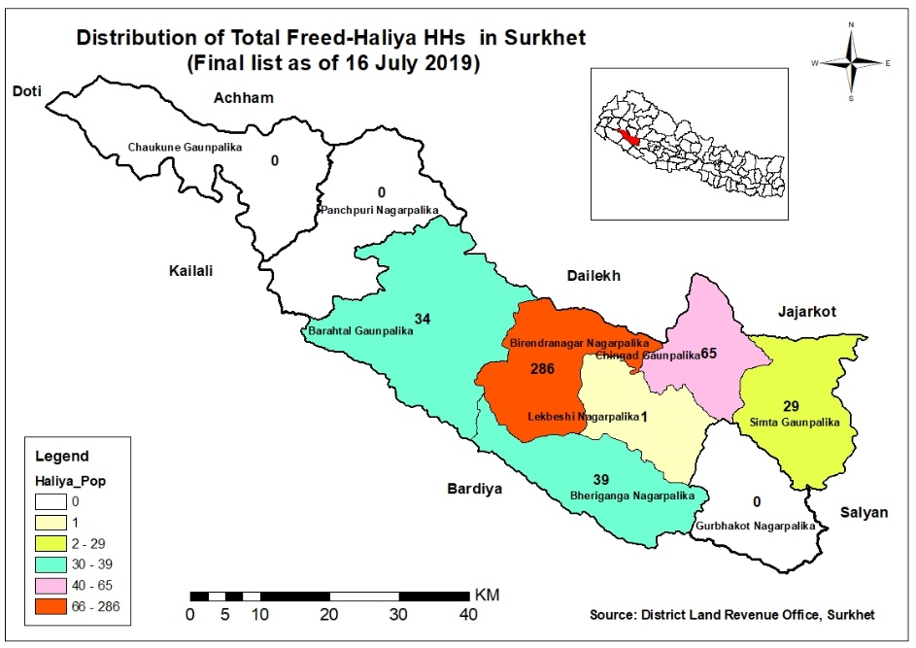
Therefore, only 454 freed-Haliya became entitled to get government rehabilitation package. The population of the verified freed Haliya is found to be scattered across 18 wards of six rural/municipalities (namely- Barahtal, Bheriganga, Birendranagar, Chingad, Lekbeshi and Simta) in Surkhet (See Table-2). Of the total of 454, almost 63% (i.e. 286) freed-Haliya live in Birendranagar Municipality. The second largest proportion (14.3% i.e. 65) live in Chingad rural municipality. The proportion of freed-Haliya in Bheriganga, Barahtal, Simta and Lekbeshi is 8.6%, 7.5%, 6.4% and 0.2% respectively. By wards, the population of the freed-Haliyas is thinly distributed. In the eleven wards out of 18 where there are less than 20 freed-Haliyas. The three wards have more than 20 but less than 40 freed-Haliyas. The rest four wards have 65 to 78 freed-Haliyas.

Social diversity and geo-graphic distribution of freed-Haliya in Surkhet
Out of the total 454 freed-Haliya population, 50.2 percent were from the Dalit community. The second largest population was from the Tharu community (i.e. 41.4 percent). The proportion of freed-Haliyas from Hill Janjati and Khas Arya community was relatively lower at 6.6 percent and 1.8 percent respectively (See Table-2).

Table 2: Freed-Haliya HHs distribution in different locations by caste and ethnicity
SN | Rural/Municipality – Ward | Freed-Haliya HHs by Caste/Ethnicity |  |  |  | Total HHs | %
 |  | Dalit | Hill Janjati | Khas Arya | Tharu
1 | Barahtal – 1 | 9 |  | 1 |  | 10 | 2.2%
2 | Barahtal – 2 | 24 |  |  |  | 24 | 5.3%
3 | Bheriganga – 8 | 33 | 3 | 3 |  | 39 | 8.6%
4 | Birendranagar – 1 | 2 |  |  |  | 2 | 0.4%
5 | Birendranagar – 10 | 35 |  | 5 | 36 | 76 | 16.7%
6 | Birendranagar – 12 | 9 |  | 1 |  | 10 | 2.2%
7 | Birendranagar – 2 | 1 |  | 2 | 75 | 78 | 17.2%
8 | Birendranagar – 3 |  |  |  | 16 | 16 | 3.5%
9 | Birendranagar – 4 | 11 |  | 3 |  | 14 | 3.1%
10 | Birendranagar – 5 | 1 |  | 1 |  | 2 | 0.4%
11 | Birendranagar – 7 | 1 | 1 | 2 |  | 4 | 0.9%
12 | Birendranagar – 8 | 3 |  | 2 | 3 | 8 | 1.8%
13 | Birendranagar – 9 | 14 |  | 4 | 58 | 76 | 16.7%
14 | Chigad – 6 | 61 | 3 | 1 |  | 65 | 14.3%
15 | Lekbeshi – 6 | 1 |  |  |  | 1 | 0.2%
16 | Simta – 2 | 15 | 1 | 5 |  | 21 | 4.6%
17 | Simta – 8 | 7 |  |  |  | 7 | 1.5%
18 | Simta – 9 | 1 |  |  |  | 1 | 0.2%
 | Total HHs | 228 | 8 | 30 | 188 | 454 | 100.0%
 | % | 50.2% | 1.8% | 6.6% | 41.4% | 100.0%
Source: Analysis from the data record of Land Revenue Office, Surkhet (FY 2018/19).

4.5 Organizational network of freed-Haliya in Surkhet
The Freed-Haliya families have their organizations at regional, district and local levels. Ratriya Mukta Haliya Samaj Federation (RMHSF) is on the top, and its central office is located in Dadeldhura district. Rastriya Haliya Mahasangh (RHMS) was formed to create awareness and public advocacy on Dalits and Haliya’s rights, mainly in Sudurpaschim and Karnali Province of Nepal with the main purpose of liberating the Haliyas, resettling them, protecting their activities and families against economic vulnerabilities and working to abolish all forms of bonded labor in Nepal. Similarly, there are District organizations of freed-Haliya (i.e. District Mukta Haliya Samaj-DMHS) under RMHSF.

The DMSH was formed in 2013 in Surkhet. As per FGDs and KII, few respondents represent Haliya organizations at district and local levels. Some leaders of DMHS were active and in regular contact of government authorities and advocating for the issues of freed-Haliya. But, only few executive members were active. The DMHS's membership network and activism was confined to the Birendranagar municipality and adjoining rural/municipalities. The lack of resources, and office space in an accessible location were constraints for DMHS.
There was a lower representation of women in Haliya representative organizations. The participants were also asked about the role of women in Haliya organizations, only few perceived the influential role of women and these communities really had minimum women representation in leadership. However, respondents admitted that women's issues are also raised in decision making of Haliya organization. It was found that the education, gender biased social norms and leadership skills are a key barrier for women to be effective in the leadership role.

EXISTING LIVELIHOOD SITUATION AND NEEDS OF FREED-HALIYA IN SURKHET

Diversification of livelihood activities and trajectories during last 10 years
From the FGDs in the selected sites, it was found that agriculture, labour works and traditional occupations have been the major sources of earning for the freed-Haliya families at the local level. The adults who were Haliya in the past, were mainly involved in labour works. The labour works were mostly masons and unskilled labourers. Some of them were involved in traditional occupation based livelihood activities like tailoring, leather work, iron works, etc. There was no significant change in livelihood options of the freed-Haliya families during last 10 years after the government declared them free. A very negligible number of family members of the freed-Haliya were engaged in salaried jobs like police, army and driver. This was found mainly due to lack of education, exposure, confidence. It was also associated with their incompetency and the issues of discrimination and non-preference existing in the community. In some locations, the remittance income has been major source of livelihoods of the freed-Haliya families.

Major income/livelihood sources and wage rate at local level
The agricultural production and income of freed-Haliya in the study areas was at the subsistence level. A few respondents were involved in the regular salaried jobs. The labour work was the main source of cash income to the majority households. The data of 42 freed-Haliya families also indicates that only 2% were earning their livelihood from regular salaried jobs. The rest were involved in skilled and unskilled labour works.
Table 3: Major income sources and skill types by caste/ethnicity
SN | Major Income Source/ Skill Types | Caste/Ethnicity
 |  | Dalit | Hill Janajati | Khas Arya | Tharu | Total | %
1 | Black Smithy, Carpentry & Labour | 2 |  |  |  | 2 | 4%
2 | Carpentry | 1 |  |  |  | 1 | 2%
3 | Mason | 10 |  |  | 5 | 15 | 36%
4 | Police | 1 |  |  |  | 1 | 2%
5 | Self-learned tailoring & labor | 3 |  |  |  | 3 | 7%
6 | Unskilled/ labour | 13 | 1 | 2 | 3 | 19 | 45%
7 | Educated unemployed & Labour | 1 |  |  |  | 1 | 2%
 | Grand Total | 31 | 1 | 2 | 8 | 42 | 100%
Source: Data analysis from mini survey administered among 42 respondents (July 2019).
The Section-7 (1) of the Labour Act, 2017 of Nepal prohibits gender based discrimination in remuneration for the equal value of work. The Section-7 (2) further defines the criteria to determine the work of equal value. In practice, the provisions have not been fully adopted in the labour market.
The wage rate differed by rural-urban locations both for skilled and unskilled workers. The wage rate ranges from Rs.500 to Rs.1200 per day. In the study areas, the masons were able to find work up to 22 days in a month. Likewise, the unskilled labourers were working up to 17 days in a month.
he wage rate was not equal for men and women, even for doing exactly the same work.
The wage rate for women was Rs. 100 less than their male counterparts.
This raises their level of economic vulnerability as they have larger families to support with a lower income.

Coping Strategies
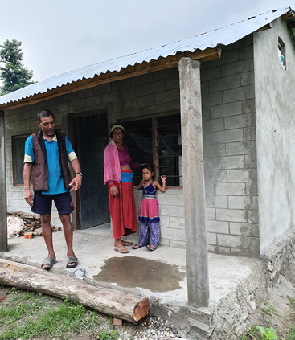
In order to cope with the livelihood shocks, the freed-Haliya families were engaged in more than one livelihood activity. They have been earning their livelihood mainly from wage labour. They also do farming in the agricultural season on their own as well as landlord's field in turns. There was also evidence of high migration to India from this community in search of income opportunities, to cope with the livelihood problem. They also do traditional occupations like tailoring, iron works, fishing, etc. There were also instances of borrowing from local groups, cooperatives and settlement development committees. Some times, they even had to sell their small assets and ornaments. For an instance, Ram Bahadur BK of Thapadera, Barahtal Rural Municipality shared his plight during the FGD, that he had to sell her wife's small ring for her treatment few months back when she was sick.
Picture 3 Ram B. B.K and his wife, at Thapadera

Migration for employment
The quantitative data collected during FGDs showed that a high seasonal migration trend among freed-Haliya families. For instance, out of 42 respondents asked about the migration, at least one family member of 32 respondents (i.e. 76%), had migrated for employment. The main migration destination was to India. In recent days, the youth were migrating to gulf countries as well. The seasonal migration trend was very high among the Dalit community. This migration was mainly in search of livelihood options. Given their low or lack of skills, they were unable to find income generating sources throughout year and they were forced to search for labor work in India. However, the trend was very opposite in the Tharu communities compared to Dalit, as they were working in the villages and had low rate of migration to search of employment opportunities (See Table-4). This might be due to fact that the Tharu community were found to have their own land (4 respondents out of 8 Tharu respondents) and might have adopted agricultural practices as employment alternatives.
Table 4: Migration destinations by caste/ethnicity
SN | Migration destinations | Caste/Ethnicity
 |  | Dalit | Hill Janajati | Khas Arya | Tharu | Total | %
1 | India | 21 |  | 1 |  | 22 | 52%
2 | Golf Countries | 5 | 1 | 1 | 1 | 8 | 19%
3 | Outside district (Police/ Army) | 1 |  |  |  | 1 | 2%
4 | No Migration | 4 |  |  | 7 | 11 | 26%
 | Grand Total | 31 | 1 | 2 | 8 | 42 | 100%
Source: Data analysis from mini survey administered among 42 respondents (July 2019).

Access to land and housing
The access to land was very limited in Haliya community study sites. It was found that most of the freed-Haliyas did not have their own registered land. Now, they possess 6 to 10 Dhur land purchased by the government under the rehabilitation program. In order to estimate the land holding status of the freed-Haliyas in Surkhet, 42 participants FGDs were specially asked about their land holding and ownership. Out of 42 respondents, only 4 respondents (i.e. 10%) had their own land before the rehabilitation, the rest 38 have received governmental support for land access. Some of them have been holding a white card with land of up to nine Ropani.
Table 5: Land ownership status before rehabilitation by caste/ethnicity
SN | Land ownership status | Caste/Ethnicity
 |  | Dalit | Hill Janajati | Khas Arya | Tharu | Total | %
1 | Previously landless (Now have Govt. provided land) | 31 | 1 | 2 | 4 | 38 | 90%
2 | Own Land |  |  |  | 4 | 4 | 10%
 | Grand Total | 31 | 1 | 2 | 8 | 42 | 100%
Source: Data analysis from mini survey administered among 42 respondents (July 2019).

In the case of Bheriganga Municipality, the government purchased/provided land in another municipality (i.e Gurbhakot) where they have constructed their houses. According to the FGD participants however, this new location is very far from their original homes and there was difficultly making the adjustments. More specifically, the current houses are built on a very small pieces of land. For some families, the land was just enough for housing and there was not enough space for agricultural practices or livestock rearing, for instance, for goat, buffalo and pig rearing.

Access to natural resources
The freed-Haliya families were found to be living near to the river and forest (jungle). Some of them, particularly in Barahtal Rural Municipal, were victims of a flood in 2015. The Freed-Haliya living near to the Bheri River, collect stones and sand from the riverbank. Nonetheless, there is little scope for riverbank farming by the freed-Haliya families as the forests are also mostly community managed. Therefore, individual freed-Haliya families are unable to earn their livelihood from forest resources. Despite living close to the nature, they were still deprived to fully utilize these natural resources for sustaining their livelihoods, especially forest resources.

Access to banking and financial services
The FGD participants were also asked about their involvement in groups and cooperatives. In all FGD locations, the freed-Haiya family members were involved either in saving-credit groups or cooperatives. The freed-Haliya have been saving Rs.50 to Rs. 200 every month in their respective groups and cooperatives. Some of them were saving up to Rs.1000 each month as they were members of different groups and cooperatives. The data Table-6 also indicates the availability of the services of Banks, Financial Institutions and Cooperatives in different local levels in Surkhet district. They borrow from such groups and cooperatives to fulfill their financial needs. As per the compulsory provision to get the government rehabilitation package, all of the freed-Haliyas families have also opened at least one their own bank accounts.

Table 6: No. of Banks, Financial Institutions and Cooperatives by Rural/Municipalities
S. N. | Name of municipals | No. of Cooperatives | No. of Banks & FIs by Categories
 |  |  | A | B | C | D | Total
 | Barahtal Rural Municipality | 47 |  |  |  |  | 0
 | Bheriganga Municipality | 69 | 3 |  |  | 4 | 7
 | Birendranagar Municipality | 257 | 23 | 2 |  | 5 | 30
 | Chaukune Rural Municipality | 27 |  |  |  |  | 0
 | Chingad Rural Municipality | 24 |  |  |  |  | 0
 | Gurbhakot Municipality | 69 | 1 |  |  | 4 | 5
 | Lekbeshi Municipality | 54 | 0 |  |  | 0 | 0
 | Panchapuri Municipality | 54 | 2 |  |  | 2 | 4
 | Simta Rural Municipality | 25 |  |  |  | 1 | 1
 | Total | 626 | 29 | 2 |  | 16 | 47
Source: Profile of Rural Municipalities and Municipalities of Surkhet District (2014).

Information and access to government's transfer programs and budget
The freed-Haliya family members were aware of social security schemes of the government including the old-aged pension. They had no any big issues about the access to social security schemes. The FGD participants were also asked about their awareness on local planning and budgeting processes. Most of them were found to be very reluctant and had no information about the local budget process. They also lacked information on targeted programs for their livelihood sustainability and had not initiated or organized efforts to advocate with local government for any targeted programs for their economic empowerment and sustainable livelihood. They even do not know how much money is spent by their wards and municipality. They were also unknown about the inclusion schemes in the government programs.

Access to amenities and basic services
The landless and homeless freed-Haliyas have been resettled to new locations mostly far from their previous habitats. The lack of electricity, drinking water, toilet facilities and easy road access to reach houses were important needs of the freed-Haliya families in the new settlements. However, their houses were built on small areas of land and there were no other basic amenities. According to the respondents, there was also problems of income generating sources in those new areas, the labor demand was unknown and they were more exposed to economic vulnerability in settlements under the rehabilitation program.
Picture 4: Newly constructed houses at Bhimpur Danda, Gurbhakot-14 for freed-Haliyas of Bheriganga Municipality

Education level of freed-haliya families
The highest education level of the freed-Haliya families was grade 12. Based on an analysis of 42 responses, the largest proportion-45 percent of households had secondary level education. The second largest, 40 percent had only basic education. The proportion of literate and higher secondary was 7 percent.
Table 7: Max. Education level of family members by ID categories
SN | Max. education level of family members | ID Category |  |  |  |  | %
 |  | A | B | C | D | Total
1 | Basic | 8 | 7 | 0 | 2 | 17 | 40%
2 | Secondary | 9 | 5 | 0 | 5 | 19 | 45%
3 | Higher Secondary (10+2) | 2 | 1 | 0 |  | 3 | 7%
4 | Literate |  | 3 | 0 |  | 3 | 7%
 | Grand Total | 19 | 16 | 0 | 7 | 42 | 100%
Source: Data analysis from mini survey administered among 42 respondents (July 2019).

The majority of family members aged 18 to 35 years were below SEE ranging from grade-3 to grade-9. Young members i.e. son, daughter and daughter-in-law of freed-Haliya were educated. The adults who worked as Haliya were hardly literate. Most of them were sending their children to school. However, the previous trend and their current economic hardship indicated that there is a high chance of children dropping-out. This literacy and numeracy among those aged 18 to 35 years looks enough for level-1 training. The English understanding of the participants seems poor. In comparison to the sons, the daughters and daughter-in-laws had higher grade of education in freed-Haliya families.

Skill training received and utilization
Only few Haliya family members mostly women (about 13% of total respondents) in the study areas have received formal skill training. The trainings were provided by local NGOs, such as Sundar Nepal and other development projects of Government and INGOs. The training was not Haliya specific. Tailoring was a major formal skill preferred and learned by the Haliya community. Those who acquired good tailoring skills, most of whom were women, were self-employed and satisfied with their earnings. They have been earning up to Rs. 22,000 per month simultaneously while doing their household chores. The successful persons have made additional efforts to advance their skills. They have worked as an intern or a semi-paid employee, and sharpened their skills. The persons with driving skills were also employed. The majority of skilled persons in the communities had gained skills through a learning by doing process from their guardians and other people in their village. These included mason, tailors, black smiths and street cobblers. However, their skills were not certified by the authority. In recent days, they need a certificate to obtain work opportunities in city areas, including in government construction site. Due to the lack of formal certification of their skills, they have been excluded from big construction works. They have to compromise with the contract amount as well as in wage rate. Therefore, masons are very interested in having their skills certified.

Traditional occupations and potentials
The Haliya community, particularly from Dalits have their own traditional occupation which they learnt from and have continued from their ancestors. The traditional occupation are being transferred from generation to generation through the informal and experiential learning. These occupations have a high potential to improve their livelihood if given proper verification and certification. These occupations can be locally industrialized so that these communities can work in a decent environment and with dignity. These traditional skills play important role in sustaining the livelihood of Haliya communities. These skills mainly includes leather works/shoe making (cobbler), iron works (Blacksmith), gold smith, and tailoring.
Leather works/shoe making (cobbler): According to successful leather work entrepreneurs in Birendranagar, they need skilled artisans (Kaligarh) as they have initiated to establish a company named Karnali Leather Production Pvt. Ltd. They will invest around 10 million in the company which is expected to provide direct employment to 50 people, and generate employment to 700 people across Karnali province. Currently, a shoe making entrepreneur in Birendranagar has been providing employment for 3 to 5 Kaligarh. A shoe making Kaligarh can earn up to NRs. 40,000 per month in Surkhet. There are street cobblers too in Birendranagar and some of them are from freed-Haliya families. The street cobblers can earn from NRs. 1000 to NRs. 2000 per day in Birendranagar areas. A trader of raw materials for leather work was doing monthly transaction of up to NRs. 800,000. According to leather work entrepreneurs, they need a relatively longer term for training of one year to two years to be a good Kaligarh. The leather work skill seems viable for current and demanding for future, and therefore, would be a potential area for freed-Haliya (Please also see case study-1 below).

Case I: Recognition of Shawar Leather in Karnali
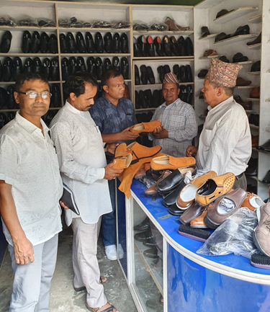
The shawar leather is famous as a local brand produced through traditional indigenous technology which has gained its recognition as a Karnali product. The government and civil society stakeholders also mentioned about shawar leather during FGDs and KII in Birendranagar. The shawar leather is a local product which is difficult to collect to produce shawar.
The shawar leather production started in Dailekh district. Mr. Sher Bahadur Bayalkoti of 60 years, previously from Dailekh district, was a pioneer person to produce and promote the shawar leather. He first learned shoe making in 1979, and started his struggle from Dailekh. He transferred his skill to his brother and sons. Over the years, he and his family started mass production and expanded their business. Since 1994, he has been operating his business in Birendranagar. From this year 2019, his brother has also started a showroom of locally produced shoes in the heart of Brendranagar. The local shoes are durable, but there is high competition with good finishing and low priced imported shoes. So far, the marketing strategy of local shoe makers is not strong enough. They have started to advertise through local FM radios but other means have not been used. The Bayalkoti brothers are also the main initiators for Karnali Leather Production Pvt. Ltd. They have also been trying to leverage resources from the government programs. The investor group of this company aims to create a decent environment and dignity for cobblers so that the youths would embrace their traditional skills and use it to sustain their livelihood. It will also reduce the dependency on imported leather. The leather work business is dependent on raw materials. The raw material comes from China and India. Finally, Mr. Bayalkoti shared that the traditional occupation based entrepreneurs still have to face the challenges to promote and sustain their business due to their caste status in their society. The government and non-government agencies should support their initiatives.
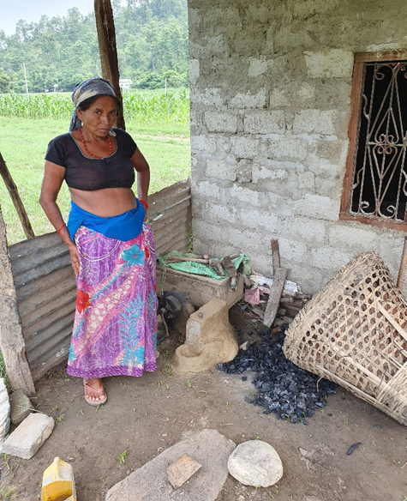
Iron works (blacksmith): The artisans of iron work in the study areas had not been formally trained, but some of them had a good art and skill. All of the black smiths were not able to feed their families from this occupation alone however, and therefore, were also working as a mason/labourer. They did not have good equipment to operate their business properly.
Picture 5 Workshop of a Blacksmith at Thapadera
Gold smith: The Kaligarh for gold smith was also a demanding skill in city areas. A good Kaligarh can earn up to NRs. 40,000 to 50,000 per month.
Tailoring: In the study areas, most of the tailors from traditional caste groups were applying their inherently transferred skills, and were not formally trained. They were working seasonally. Nowadays, the tailoring occupation has been adopted by non-Dalits too particularly by women. The trained women from Tharu community were earning up to NRs. 22,000 per month.
Despite the strengths outlined here, the traditional skills are fast disappearing. These skills when utilized and enhanced could have a high competition with imported goods and substitute them since they are of a superior quality and more durable. All they need is a proper marketing structure, advertisement and governmental support to enhance, institutionalize and certify their skills. In the study sites, many Haliya households also highlighted that the youths have deviated from the traditional skills and are instead engaged in other less productive works because of the dignity associated with the traditional work. Therefore, their demand was also related to institutionalizing and certifying their skills through governmental provision so that the youths could accept their traditional skills. The following steps could assist in halting the decline: i) Strengthening the organizations of respective caste based occupation, and raising their voice with a single independent national level federation; ii) Raising awareness among the traditional workers to eradicating feudal form institutions Balighare, Khalo, Khan pratha; iii) promotion and extension of market networks nationally and internationally; and iv) training and education (like TVET) for the human resource development to respond the possible challenges. The state must make special efforts to modernize Dalits caste based occupation through opening Dalit cooperatives. This will enhance their collective bargaining power on one hand, and to respond natural (inevitable) and sudden changes caused by the global markets on the other hand.

Social mobility of women
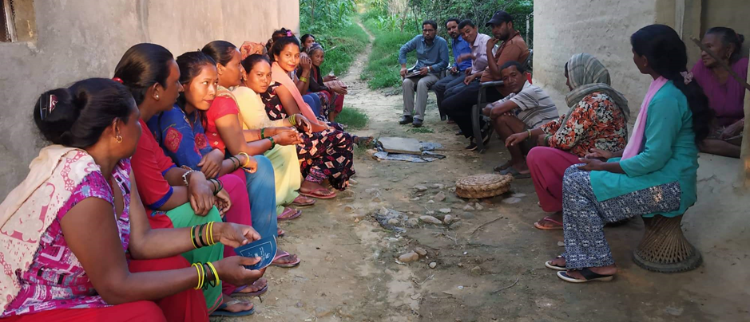
In order to understand the gender empowerment and mobility of women, a special FGD was organized at NayaGhusra of Birendranagar-10. There were a total of 13 participants (10 aged 18 to 35 years, and the rest 3 were above 35 years). The women involvement in unpaid care work was high. Women were main responsible to cook and feed the family members. The figure shows that all respondent women had moved out of their village for different purposes. The purpose of women movement was mainly for shopping, selling vegetables, participate in programs, labour work, and exposure visit. Usually, women do not move alone outside their village. In many cases, they move outside with their family member or villagers.
Picture 6 Participants at Naya Ghusra, Birendranagar-10, Surkhet.
Figure-1: Domains of women's movement
Source: FGD data (July 2019)
Moved
Outside
Country
= 1/13
Moved
Outside
District
= 8/13
Moved
Outside
Village
= 13/13
Total women respondents = 13

GENERAL INFORMATION ABOUT LABOR MARKET SITUATIONS IN SURKHET

Labour force/working age population in Surkhet
The Table 9 shows the working age of population in Surkhet. Generally, the age group of 15 to 59 years is considered to be economically active and this population is the major source of working force in the Nepalese context. However, in backward and exploited communities, all age groups from children to older adults are forced to engage in labor force. Of the total population in Surkhet, about 25.2% were of age group 10 to 19 years, meaning they are the potential working force in the coming future. The working age is generally considered to be from 20 to 59 years which contributes about 44.8 % of the population, meaning if mobilized properly, Surkhet does not seem to have labor force problem.
Table 8: District Population by 10/10 Years Age Groups in Surkhet
SN | Age Group (Year) | Population | Percentage
1 | 00 to 09 | 86,218 | 24.6%
2 | 10 to 19 | 88,383 | 25.2%
3 | 20 to 29 | 61,214 | 17.4%
4 | 30 to 39 | 42,147 | 12.0%
5 | 40 to 49 | 29,874 | 8.5%
6 | 50 to 59 | 20,624 | 5.9%
7 | 60+ | 22,344 | 6.4%
 | Total | 350804 | 100.0%
Source: Profile of Rural Municipality and Municipalities of Surkhet District, CBS Surkhet Office (2017)

Formal and informal employment by industry in Nepal
The Nepal Labour Force Survey 2017/18, has analyzed a sample of industry wise formal and informal employment status. The Table-9 below shows the sector wise formal and informal employment status in Nepal. The majority of sample (84.6%) in Nepal were found informally employed while only 15.4 percent were employed formally. Of formal employment, human health, social work, technical and scientific areas and financial and insurance activities had a significantly higher number of formal employees whereas household and real estates had high informal employment. Among the total employees, about 21 percent were engaged in agricultural related employment, while about 17 percent were engaged in motor sales and repairs. Real estate, arts and recreation had comparatively lower number of employees. Also, there was high engagement of females in agriculture and human health and social work sectors while they had a lower representation in transportation, storage and electricity, gas and air conditioning supplying industries.
Table 9: Formal and informal employment by industry in Nepal
Nepal Standard Industrial Classification | Total Employee (Sample) | Formal employment (%) | Informal employment (%) | Female Employee (%)
A Agriculture, forestry and fishing 3) | 1523 | 3.1% | 96.9% | 57%
B Mining and quarrying | 59 | 3.4% | 96.6% | 27%
C Manufacturing | 1072 | 12.5% | 87.5% | 33%
D Electricity, gas, steam and air conditioning supply | 322 | 4.3% | 6.2% | 2%
E Water supply; sewerage, waste management and remediation activities | 42 | 21.4% | 78.6% | 21%
F Construction | 978 | 2.5% | 97.5% | 11%
G Wholesale and retail trade; repair of motor vehicles and motorcycles | 1240 | 22.4% | 77.6% | 44%
H Transportation and storage | 322 | 21.7% | 78.3% | 2%
I Accommodation and food service activities | 371 | 17.8% | 82.2% | 45%
J Information and communication | 60 | 35.0% | 65.0% | 22%
K Financial and insurance activities | 118 | 36.4% | 63.6% | 47%
L Real estate activities | 17 | 11.8% | 88.2% | 18%
M Professional, scientific and technical activities | 44 | 36.4% | 63.6% | 20%
N Administrative and support service activities | 64 | 37.5% | 62.5% | 11%
P Education | 558 | 26.5% | 73.5% | 46%
Q Human health and social work activities | 171 | 37.4% | 62.6% | 54%
R Arts, entertainment and recreation | 34 | 32.4% | 67.6% | 12%
S Other service activities | 156 | 20.5% | 79.5% | 24%
Private households | 73 | 0.0% | 100.0% | 66%
Activities of extraterritorial organizations and bodies | 18 | 27.8% | 66.7% | 28%
Total | 7086 | 15.4% | 84.6% | 37.3%
Source: Nepal Labour Force Survey 2017/18, CBS, GON

Number of establishments and persons engaged by classification in Surkhet
According to Nepal Economic Census 2018, there were a total of 7076 establishments in Surkhet district which is just 0.8% of total establishments in Nepal. The number of persons engaged by establishment was 5.1 for Surkhet in comparison to the national average of 3.1. Table 10 shows that the wholesale and repair trade and repair of vehicles and motor was the sector with large numbers of industrial establishment in Surkhet and then followed by the manufacturing sector with 3,535. The hotel and accommodation sector stand in third largest. The agriculture and education sector had satisfactory engagement of people while real estate activities had less engagement in Surkhet overall.
Table 10: Number of establishments and persons engaged by classification
Nepal Standard Industrial Classification | Nepal |  |  | Surkhet
 | # of Establishments by SIC | # of Persons Engaged by SIC | # of Persons Engaged by per establishment | # of Establishments by SIC | # of Persons Engaged by SIC | # of Persons Engaged by per establishment | % of establishments to national total
A Agriculture, forestry and fishing 3) | 106,410 | 106,410 | 1 | 557 | 557 | 1 | 0.5%
B Mining and quarrying | 7,726 | 7,726 | 1 | 46 | 46 | 1 | 0.6%
C Manufacturing | 510,523 | 510,523 | 1 | 3,535 | 3,535 | 1 | 0.7%
D Electricity, gas, steam and air conditioning supply | 20,170 | 20,170 | 1 | 57 | 57 | 1 | 0.3%
E Water supply; sewerage, waste management and remediation activities | 15,312 | 15,312 | 1 | 99 | 99 | 1 | 0.6%
F Construction | 14,750 | 14,750 | 1 | 95 | 95 | 1 | 0.6%
G Wholesale and retail trade; repair of motor vehicles and motorcycles | 498,069 | 988,346 | 2 | 7076 | 13225 | 1.9 | 1.4%
H Transportation and storage | 3,182 | 20,027 | 6.3 | 55 | 247 | 4.5 | 1.7%
I Accommodation and food service activities | 130,540 | 346,273 | 2.7 | 1609 | 3920 | 2.4 | 1.2%
J Information and communication | 2,796 | 39,789 | 14.2 | 24 | 380 | 15.8 | 0.9%
K Financial and insurance activities | 17,996 | 206,979 | 11.5 | 186 | 3106 | 16.7 | 1.0%
L Real estate activities | 207 | 1,977 | 9.6 | 2 | 8 | 4.0 | 1.0%
M Professional, scientific and technical activities | 8,204 | 33,254 | 4.1 | 78 | 218 | 2.8 | 1.0%
N Administrative and support service activities | 6,873 | 45,999 | 6.7 | 38 | 145 | 3.8 | 0.6%
P Education | 40,839 | 513,336 | 12.6 | 665 | 7380 | 11.1 | 1.6%
Q Human health and social work activities | 19,990 | 164,498 | 8.2 | 193 | 1122 | 5.8 | 1.0%
R Arts, entertainment and recreation | 2,821 | 16,062 | 5.7 | 13 | 31 | 2.4 | 0.5%
S Other service activities | 57,514 | 177,026 | 3.1 | 397 | 1737 | 4.4 | 0.7%
Total | 923,356 | 3,228,457 | 3.5 | 7076 | 35,908 | 5.1 | 0.8%
Source: Nepal Economic Census 2018, CBS, GoN

Employment status in Surkhet
The employment status in Surkhet seemed satisfactory. Out of the total sample size, about 73.9 percent were self-employed while only 1.6 percent were employers. Employees contributed about 21% which seems to be a comparatively good position in Surkhet. This shows that the majority of people in Surkhet are self-employed meaning that they earn their livelihood by themselves and hence might have followed traditional and self-learned skills which when enhanced would help them sustain their livelihood. While more women were self-employed as compared to men, more men were employees (about 31.5%) as compared to women (21%). This might be due to restrictions and non-preference of female members to work away from home. While unpaid family work for men was significantly less for men (0.7%), about 1.7 percent female were working as unpaid family workers only.
Table 11: Employment Status in Surkhet
SN | Employment Status | Total |  | Male |  | Female
 |  | No | % | No | % | No | %
1 | Employer | 2,074 | 1.6% | 1,346 | 2.0% | 728 | 1.2%
2 | Employee | 26,914 | 21.0% | 20,787 | 31.5% | 6,127 | 9.9%
3 | Self-Employee | 94,532 | 73.9% | 42,124 | 63.8% | 52,409 | 84.6%
4 | Unpaid Family Workers | 1,569 | 1.2% | 492 | 0.7% | 1,076 | 1.7%
5 | Not mentioned | 2,905 | 2.3% | 1,298 | 2.0% | 1,608 | 2.6%
 | Total | 127,994 | 100.0% | 66,047 | 100.0% | 61,948 | 100.0%
Source: Profile of Rural Municipality and Municipalities of Surkhet District, CBS Surkhet Office (2017)

Labour migration (in and out-migration) in Surkhet
The labor requirement and involvement of the freed-Haliyas in work seems contrasting in Surkhet. They face high competition from laborers from India who work at lower wage rate and are subsequently forced to reduce their wage rate. The seasonal in-migration of Indian labors in Surkhet has caused unemployment issues for freed-Haliyas. Also, they face competition from the migrants of high hills and mountains who migrate to Surkhet seasonally in search of employment.
Figure 2 In- and Out-Migration in Surkhet (Census 2011)
The figure-2 attributes that the in-migration rate is higher to out-migration rate in Surkhet.
This has caused freed-Haliyas to migrate either to India or to gulf countries in order to sustain their livelihood as shown by the migration rate reported by respondent households (a household member from 30 out of 42 respondent households had migrated for work at some point). Also, most of the freed-Haliya members especially young members of Bhimpur danda, Gurbakot-14 (Maintada) had a good opportunity to get foreign employment and they have already been working in the foreign countries and remittance is the major source of their livelihood income.

Major market centers in Surkhet
Birendranagar Municipality (BNM) of Surkhet district is the capital city as well as the capital market of the Karnali Province. This is the gateway of remaining nine districts (Dailekh, Salyan, Jajarkot, Rukum, Kalikot, Jumla, Mugu, Dolpa and Humla) of this province. It is the major hub and collection center for most of the surrounding municipals and has interconnected linkages with other internal and Indian markets. The Table-12 shows that there at least 6 market centers in each local levels in Surkhet.
Table 12: Market centers by Rural/Municipalities of Surkhet Districts
S. N. | Name of municipals | No. of Market Centers | Name of market centers
 | Barahtal Rural Municipality | 8 | Sano Traranga, Lamakhali, Biureni, Ranighat, Thapadera, Baddichaur, Sirupata, & Dhimighat Bazars.
 | Bheriganga Municipality | 6 | Chhinchu, Babaibazar Khola Wari, Jahare, Jatri, Ramghat, & Sattari ra Pasatthi Bazars.
 | Birendranagar Municipality | 11 | Yarichowk, Tempochowk, Cheda Bazar, Mehali, Karekhola, Pipira, Dhuliyapit, Devasthan, Ghusra, Bamekhola & Berendranagar Bazars
 | Chaukune Rural Municipality | 10 | Gutu, Pul Bazar, Ghatgau/Chhal, Basanti Gunta, Betan, Lagam, Dhanrash, Bijaura, Mayatal & Toshra Bazars
 | Chingad Rural Municipality | 9 | Dhadkhet, Dharampokhara, Bheltakuri, Birkham, Bhairabshatan, Thatibazar, Dhadkhet, Gogane and Dhadkhet.
 | Gurbhakot Municipality | 11 | Shrinagar, Krishnanagar, Pulbazar, Shuraghat, Raikarbazar, Gauri bazar, Kharigaira, Birechaur, Pabitra bazar, Gaile & Bote Bazars
 | Lekbeshi Municipality | 11 | Syaulibazar, Dasarathpur, Gamkhola, Chyarkule, Baragaun, Mjhuwa, Mahendranagar, Gangate, Chaurashe, Narajale & Badipati Bazars
 | Panchapuri Municipality | 10 | Simtachaur, Dhunge, Aankot, Dhunge, Bagbazar, Babiyachaur, Chature, Bidhyapur, Palaite & Chaur Pulbazar.
 | Simta Rural Municipality | 14 | Deuli, Kalikhola, Gojibazar, Kafalkot, Dhunidaha, Bahakharka, Aale bazar, Pipalpata, Jamune bazar, Pulbazar, Bajeda aaili, Lipechaur, Danda & Jugena Bazar.
 | Total | 90
Source: Profile of Rural Municipalities and Municipalities of Surkhet District (2074).
6.7 Key sectors of labour market in Surkhet
In interaction with the respondents through FGDs and KIIs, the five major sectors of labor market were preferred and demanded locally in Surkhet. The Table- has presented in priority order. There were 10 sub-sectors which were preferred and needed by the freed-Haliyas for this skill enhancement. There were 19 sub-sectors of five main sectors where there is high demand of skilled labors.
Table 13: Key sectors and subsectors for labour market in Surkhet
Main sectors | Sub-sectors
 | Freed-Haliyas’ interest and skill needs | Employers’ demand and suggestions
- Engineering | - Mason  - House Painter  - Plumber  - Auto mechanic | - Tile and Marble Fitter  - Mason  - Gabion Weaver  - Plumber  - House Painter  - Auto mechanic  - Building electrician  - Stainless steel fabricator  - Motor cycle mechanic
- Agriculture | - Off Season Vegetable Producer  - Village Animal Health Worker  - Mushroom Producer | - Off Season Vegetable Producer  - Mushroom Producer
- Miscellaneous | - Tailoring  - Beautician  - Black smith | - Shoe Maker  - Tailoring  - Beautician  - Incense stick
- Tourism/ Hospitality | NA | - Waiter/Waitress,  - Room Attendant,  - Housekeeping cleaner
- Handicrafts | NA | - Beads, pearls and crystal’s items maker
(Field Study, 2019)
6.7.1 Skill needs and interests of Freed-Haliyas for their livelihood improvement
Across all FGD sites, the men participants showed their interest to enhance their skills for mason work. The house painter, plumber and auto-mechanic were also interest to the male participants. The most of adult men were working as masons but they have not received formal training. Due to lack of certification of their locally learned skill, they have been facing problem to get competitive work in urban areas, and government funded constructions. They were also underpaid. Youths who were working as an unskilled labour had an inspiration to increase their wage rate and income after the skill training. The women participants showed interest on tailoring and beautician. They were also inspired from the good income of some skilled women in their communities. Some males who have been working as tailors or belong to tailor families seemed aspired to expand their market at local level if they could acquire skills to make school dress and others clothes as per young people's needs. Though the number was small, some participants justified the need of few Village Animal Health Worker (VAHW). According to communities near by urban areas, the off-season vegetable and mushroom are attractive as these produce get market and price easily
6.7.2 Demand of skilled labour in Surkhet
From the labour demand perspective, the engineering sector stands in the first and fast expanding sector in Surkhet. According to contractors and local people, the engineering sector has been facing a deficit of skilled labour. There is a high demand for masons, tile and marble fitters, gabion weavers, plumbers, house painters, auto mechanics, motor cycle mechanics, building electricians and stainless steel fabricators in the engineering sector.
The agricultural sector also has a high demand for skilled labour. Almost two-thirds of the vegetable demand in Surkhet was fulfilled from imports. The people have started to demand local and organic vegetables. The government has also promised and increased investment for agriculture. Therefore, organic vegetables and mushrooms are highly demanded. The FGD respondents also shared that there is demand for Village Animal Health Workers.
The tourism sector is a priority for the Karnali government. According to the president of the Hotel Association Nepal (HAN), there are more than 1500 hotels in Surkhet. The Nepal Economic Census data also shows that there are 1609 establishments with accommodation and food service activities in Surkhet. The hotel entrepreneurs are seeking waiter/waitress, room attendants and housekeeping cleaners. Therefore tourism/hospitality has been seeking employees skilled in hospitality to work as waiters/waitresses, room attendants, and housekeeping cleaners.
According to local entrepreneurs, the skilled leather work artisans and tailors are also highly demanded in Surkhet district. According to Surkhet CCI, beads, pearls and crystal's items demand have also been increased in the market, and the skilled persons can earn good income after training.

Social preferences of employers
The caste and gender based discrimination is still rampant in the society. The gender role has not changed. Dalit households still cannot open teashops in the local markets. However, the situation has been a bit different in city areas in Birendranagar. According to the Chair of HAN,
the hotel entrepreneurs do not prefer caste in staff hiring rather they seek skilled persons. However, the observation shows that there is very minimum participation of women as a hotel employee. Likewise, Dalit participation also seems very low in the hotel sector. The main cause for low participation of Dalit in hotel sector seems due to lack of required skills. The fear of discrimination at work place might be another cause to make Dalit reluctant to participate in hotel sector. The restricted social mobility of women ultimately excludes them from skill and employment opportunities. There were not especial interventions to provide non-traditional skill and employment opportunities to Dalit and women.

Previous learning on skill training programs
- From the different discussions during the field work, it showed that participant selection has always been an issue. Due to improper selection process, incomplete selection criteria and the influence of vested interest and favoritism result to inappropriate participant selection which ultimately leads to failure.
- Most of the government and NGO stakeholders of FGDs shared their bitter experiences and information on non-residential trainings. According to stakeholders, only about one fourth of the participants become successful through non-residential training. The participants are not punctual and are then unable to utilize and take advantage of the full training. The participants have to travel from remote areas. Therefore, there is always a high chance of irregularities in non-residential training. This will not allow them to give productive time for the training.
- The FGD participants at community level were asked about the model of training they could not tell which one is effective either residential or nonresidential. The women participants within Birendranagar preferred non-residential training. However, they were ready to spend three months outside of the home.
- The timing of the training and duration was also a reason for irregular attendance of the participants. There are different agricultural plantation work and harvesting times between the months of May to November, which means participants are occupied. The rainy season and different festivals also fall during this period.

Cost-effectiveness, suitability, and sustainability analysis of freed-Haliya preferred livelihood options
In order to generate a recommendation on the top five livelihood options for 100 targeted freed-Haliyas in Surkhet, the study has analyzed the cost-effectiveness, suitability and sustainability of nine sub-sectors. The nine sub-sectors have been selected based on the preference of the freed-Haliyas and the demand of the skilled labor under these sectors.
- Cost-effectiveness: the cost-effectiveness analysis has considered the per-person input required (i.e. time, technology and money) for the training, and its potential outcomes (i.e. probability to be employed/start enterprise, and possible minimum income after the training). However, due to unavailability of the actual information on per person training cost, this analysis has been more qualitative. The information shared by FGD and KII participants validates the conclusion.
- Suitability: the suitability (i.e. appropriateness) is analyzed based on the land holding and housing condition, local resource base, cultural factors and social norms on caste and genders, the connection of trades to the freed-Haliya's past livelihoods, and the environmental aspects.
- Sustainability: the sustainability is assessed based on the probability to continue beyond the project, matching with government policy and priorities, and the existence of supportive institutional mechanisms at local level.
Table 14: Per Person Training Cost and Possibility of Return by Trades
SN | Preferred trades by Freed-Haliya | CTEVT short course duration | Tentative per person training cost | Need of post training support | Probability to get employed/ start enterprises | Estimated time to get return (income) | Possible min. income after the training
 | Mason | 390 hrs. | NA | Less than NRs. 20,000 | High: in private and govt. construction works | Immediately after the training | NRs. 22,000 per month
 | Junior house painter | 390 hrs. | NA | Less than NRs. 20,000 | High: in private and govt. houses | Immediately after the training | NRs. 20,400 per month
 | Plumber | 390 hrs. | NA | Less than NRs. 20,000 | High: in private and govt. houses | Immediately after the training. | NRs. 20,400 per month
 | Auto mechanic | 390 hrs. | NA | More than NRs. 20,000 | High: Own enterprise/ job in workshop | After three months. Needs further practice. | More than NRs. 25,000 per month
 | Off-season vegetable producer | 390 hrs. | NA | Less than NRs. 20,000 | High: Self-employment/ enterprise | Immediately, as per season. | NRs. 60,000 per Kathha per season
 | Village Animal Health Worker | 390 hrs. | NA | Less than NRs. 20,000 | High: Self-employment/ enterprise | Within three months. | Rs. 20,000 per month
 | Mushroom producer | 390 hrs. | NA | Less than NRs. 20,000 | High: Self-employment/ enterprise | Within three months. | NA
 | Tailoring | 460 hrs. | NA | Less than NRs. 20,000 | High: Self-employment/ enterprise | After three months. Needs further practice. | Up to NRs. 22,000 per month
 | Beautician | 390 hrs. | NA | More than NRs. 20,000 | Medium: Self-employment/ enterprise | Within three months. Needs space and investment | More than NRs. 20,000
Source: Data and information collected through FGDs and KIIs (July 2019)

- Engineering Sector
- Mason
After the implementation of federalism, both the government and private construction works have increased in Surkhet. The government needs to construct office buildings, roads and other social infrastructures in the province capital. The private house constructions have also been increasing as people want to live in the capital city. Therefore, masonry is a highly demanded trade which can ensure immediate returns to the training participants. Masonry appears to be an inherent skills among freed-Haliya groups. The social practice of caste discrimination also does not affect the entry of Dalit in new construction, and hence it seems suitable for freed-Haliya. There is a high possibility to find a good number of participants for mason training from the same or adjoining locations. Therefore, it will reduce the travel cost of a non-residential type of training. Moreover, it does not need much money for post training support to ensure work/enterprises. A mason can find work up to 22 days and can earn NRs. 22,000 per month. Therefore, it seems to be a cost-effective trade for freed-Haliyas. The skill of masonry can be used at any place and almost all the time, therefore, it can be easily continued beyond the project period.
- Junior house painter
The house painting is a complementary skill to the mason's work, and it is also highly demanded in Surkhet. Obviously, in comparison to masonry, the required number of house painters would be less. However, there was good demand of skilled house painters in Surkhet, and there is high probability to get employed/start an enterprise immediately after the training. The house painting also does not need much money for post training support, and does not need a big effort to seek market. According to FGDs and KIIs, a house painter can find work for up to 18 days in a month, and earn NRs 20,400 per month. The caste issue will not be a major for the work of the house painters. The house painters can also earn good income in foreign countries. It seems to be a sustainable skills for freed-Haliya.
- Plumber
There was high demand of plumbers in Surkhet. The demand was high in urban areas, though this skill is useful in rural areas too. A plumber should work inside the houses, and therefore, in rural areas, the caste identity of the plumbers might be a barrier to get work. In some rural areas, the non-Dalit still do not prefer Dalit plumber. However, it may not be much problematic in urban areas in case of Dalit community. Moreover, the project can find a significant number of participants from the Tharu community in the nearby city areas of Surkhet.
A plumber can start her/his enterprise immediately after getting the certificate of training. It also does not need big effort for marketing, and enterprise start up support. The plumbers can earn more than NRs. 20,000 per month. The plumbing seems a sustainable livelihood option for freed-Haliya. The plumbing skill can be utilized in many places.
- Auto mechanic
There is deficit of skilled auto-mechanics in Surkhet. According to the respondents of KII and FGDs, there are more than 1500 auto-rickshaws in Surkhet. It has been increasing every months. According to Mohan Nepali of Barahatal-2, who belongs from freed-Haliya family, informed that an auto-mechanic can earn NRs. 25,000 per month. He further informed that an Auto driver can also earn min. NRs. 1000 to NRs. 2000 per day. As the increase in the number of auto-rickshaws, the demand of driver is also increasing in the district. Compared to other trades, it needs more money and appropriate space to start the workshop. However, there is possibility to get jobs in existing workshops.
- Agriculture Sector
- Off-season vegetable producer
According to Senior Agriculture Economist of Ministry of Agriculture of the Karnali Province, about 55% of the total vegetable demand in Surkhet has been fulfilled from the import outside Karnali. The district production cover around 34% and the rest 11% from other Karnali districts. According to the Manager of Agriculture Market of Birendranagar, the demand of local and organic vegetables is increasing day by day. He also informed that the customer of city areas are ready to pay NRs 5 to NRs. 10 additional price for local vegetables. The government has also promised and increased investment for agriculture. The ASDP will be a good opportunity to leverage resources for post training investment, as it also target marginalized groups. Therefore, the vegetable production will be sustainable source of income. The freed-Haliya are also basically famers. Now, some vegetable producers have been earning NRs. 60,000 per Kattha per season. The vegetable can be produced three to four times in a year. A trained person can increase the productivity. Therefore, off-season vegetable producer looks a good livelihood options for freed-Haliya. However, it will not be suitable in all locations.
- Village Animal Health Worker (VAHW)
According to FGD participants, at least two VAHWs can earn up NRs. 20,000 per month and sustain in a village. A VAHW can start her/his business with a minimum investment. The training for VAHW cannot be non-residential as the participants should come from scattered locations. It will increase the per person training cost.
- Mushroom producer
According, FGD and KII participants, the mushroom production looks deficit in comparison to its demand in Surkhet. The hotels as well as individual customers have been increasing the demand. Therefore, there will not be a problem of market access. The mushroom producer can start their earing within three months. However, it will not be an appropriate to those freed-Haliya who have only a small house, and not enough space for even family members.
- Miscellaneous Sector
- Tailoring
Tailoring seems an attractive and good returning skill both at urban and rural markets in Surkhet. For example, in Barahatal ward no. 2, Ranighat and Thapadera market areas, there are about 500 households across the catchment areas where around 1000 students need school uniforms. Therefore, the skilled tailors can generate good income from tailoring business. Therefore, the project can organize at least one tailoring training by involving 3 to 5 participants from each market's catchment areas. After the training, some of the participants can work in city areas in Birendranagar and, if they like, they can also start group business at market centers. The tailoring does not need a big investment to start earning locally. However, an additional three month practice ensures good earning. According to Shanti Chaudhari who is also a member DMHS Surkhet, she earns up to NRs. 22,000 per month from her tailoring in the season simultaneously while doing other agricultural and household activities. In other seasons, she can earn minimum 8,000 per month. Tailoring seems appropriate both for men and women of any caste groups.
- Beautician
In some FGD sites within Birendranagar Municipality, some women participants were interested in the beautician business. However, the number was very small compared to others. Some stakeholders in Birednranagar also suggested the viability of this business.

CONCLUSION AND RECOMMENDATIONS

Conclusion
Surkhet is one of the Haliya problem stricken districts in Karnali Province of Nepal. Despite the number of discrepancies and issues regarding the rehabilitation process, the government has almost concluded the distribution of rehabilitation package to the verified freed-Haliyas in Surkhet. Out of 454 finally verified freed-Haliyas by the government, 436 freed-Haliya families have already received the government rehabilitation package, and the rest will receive their package within FY 2019/20. The field study shows that freed-Haliya families still have been living in vulnerable situations, and they need livelihood support. The facts show that the issues of freed-Haliya in Karnali has not been visible and a priority for development agencies, as there was no freed-Haliya targeted livelihood programs in the district. Therefore, the initiative of The Bridge Project seems highly relevant to the needs and constraints of the target groups in Surkhet.

Key Recommendation
    - Recommended cost-effective and target group (freed-haliya)-focused sustainable livelihood options/programs
Based on the analysis of the rights holders' needs, the demand of skilled labour by private sectors/employer community, and the development policies and priorities of the government of Karnali Province as well as the local resource base, the study has concluded that the seven sub-sectors of three main sectors (i.e. Engineering, Agriculture and Miscellaneous) seem suitable for the target group (freed-haliya). Aligning with the project objectives and targets, the study has also assessed the cost-effectiveness, and sustainability aspects, and prioritized the seven sub-sectors of livelihood which seem highly relevant for the target groups. The recommended priority is: (i) Mason, (ii) Off-season vegetable producer, (iii) Tailoring, (iv) House painter, (v) auto mechanic, (vi) Village Animal Health Worker, and (vii) Plumber. The project can select up to five or less recommended sub-sectors for conducting skill training.

    - Participants selection process and criteria for skill training
There should be a clear and comprehensive process and criteria for the participant's selection. The minimum qualification, willingness and determination of participants as well as their basic knowledge about the backward and forward markets and viability of self-employment are necessary conditions for participants' selection. The gender and equity aspects should be enough conditions for the selection criteria. An adequate planned time should be invested for participant's selection. The minimum criteria to be applied should be:
- Haliya identity card holders
- Interest and determination of the participants
- Education level (minimum requirement)
- Previous and traditional knowledge and skills
- Basic knowledge about forward and backward market
- Possible family support for during and after training
- Family size and dependent numbers
- Family members with disability
- The category of Haliya cards but it should be verified on the basis of the real poverty situation of the card holders.

    - Training model
The project should design a mixed model of training both residential and nonresidential. Due to the scattered settlements of the beneficiaries, it would be difficult to find 20-40 freed-Haliya participants in all locations. The participants from remote areas can benefit from residential training. The participants from nearby Birendranagar who are also unable to stay in the training venue can participate in the non-residential training. Moreover, if the participants are selected from different locations for a particular trades it will decrease competition when they start their enterprises or self-employment in their locations/villages/local markets. To reduce the cost of the residential training, the project can manage home-stay type of accommodation for the participants.
    - Post training and enterprise development support
Due to the destitute situation of the freed-Haliya, the skill enhancement alone does not ensure self/employment and entrepreneurship development. Therefore, the post training supports, and skill certification should be integrated. The enterprise start up support, job placement support, linkage to markets and financial access and soft skills for business development are vital to ensure a maximum increase in income of the participants after the training.
    - Appropriate calendar for skill training
The project should consider the possible negative impact of the participants' family member's engagement in seasonal agricultural works. The period from May to November seems busy period when there are different agriculture plantation and harvesting time including different festivals. The suitable time for skill training will be between the months of December to April.
    - Addressing the issues of gender equality and person with disability
The gender discrimination and stereotyping have been impacting the social mobility and productive roles of women in the community. In order to promote gender equality, the participant's selection process should encourage and facilitate women candidates to select non-traditional trades. The project should ensure the fair process so that the person with disability will have equitable access to information and participation.
    - Support for skill test
The project can provide skill testing opportunity to adult freed-Haliya who already possess a good knowledge of the trade, but are not yet certified. The adult freed-Haliya who have been earning their livelihood from daily wage works, and whose offspring are not at working age seem much vulnerable due to lack of the certified skill. The skill certification will reduce their vulnerability. This will also contribute to increase the income of freed-Haliya families at a minimum cost. The project can include them while organizing skill tests to the core targeted trainees.
    - Possible collaboration and coordination
The welcoming attitude of the MoSD in Karnali, will be an opportunity to work in cooperation particularly in the areas of advocacy and livelihood promotion. The government projects, such as the Agriculture Sector Development Programme implemented in Karnali Province would also be an opportunity for freed-Haliya. During consultation, Surkhet chamber of commerce and industries, Hotel Association Nepal, and Nepal Construction Association were also seeking skilled human resources and were ready to coordinate. Therefore, the project should maintain effective coordination with all the government and private sector actors from very beginning. It will be supportive for the sustainability of the project.
  - Policy implications and recommendations for rehabilitating freed-Hailyas
Based on the findings of this study, following policy recommendations can be made. The cross-cutting theme in these recommendations is collaboration; all the government and non-government organizations should join their forces and resources to rehabilitate freed-Haliya as it is already seen that government itself is not capable to rehabilitate all freed-Haliya.
- For Governments
- The local government should be made aware about the actual situation of the freed-Haliyas, their ID card distribution and ensured those who are in need of actual help are getting the help. For this, primary information and statistics on Haliya community needs to be prepared and updated.
- Governmental bodies should require collaboration from all the NGOs working with Haliya issues and work to rehabilitate them.
- The freed-Haliya rehabilitation issue should be strongly linked with landless people’s issue as land is considered as the indicator of wealth or prosperity.
- The act related to Haliya should be integrated with land reform issue and be enacted soon.
- For NGOs and INGOs
- NGOs should understand the situation of freed-Haliya and use local knowledge in conducting vocational trainings with freed-Haliyas. They should collaborate with governmental bodies, and make synergic efforts.
- NGOs should cooperate with each other more deeply to have a greater effect on freed-Haliya people’s lives and link Haliya issues strongly with landlessness an pressurize the government of Nepal to implement land reform that includes the Haliyas
- Donor communities
- Donor countries and communities should prioritize for uplifting the economically vulnerable group in Nepal like freed-Haliyas.

References Cited and Bibliography
- Budget Speech of FY 2019/2020, Ministry of Economic Affair and Planning, Province Government, Karnali Province.
- Labour and employment promotion policy-2018, Ministry of Social Development, Province Government, Karnali Province.
- Ministry wise progress report (FY 2018/2019), Ministry of Economic Affair and Planning, Province Government, Karnali Province
- Project document of ILO's Bridge Project in Nepal.
- Red book of 2019/2020, Ministry of Economic Affair and Planning, Province Government, Karnali Province.
- Social Development Mirror, Ministry of Social Development, Province Government, Karnali Province, Issue-1, 2018.

Annexes

Annex-1: List of KII participants
S.N. | Name | Position | Organisation | Contact Number
1 | Mr. Bipin Aacharya | Executive Director | UCEP Nepal | 9851142969
2 | Mr. Man Bahadur BK | Secretary | Ministry of Social Development, Karnali Province | 9851135282
3 | Mr. Laxmi Kumar BK | Section Officer | District Land Revenue Office, Surkhet | 9849226090
4 | Mr. Santa Bahadur Sunar | Secretary | Ministry of Economic Affair and Planning, Karnali Province
5 | Mr. Hari Pandit | Senior Agriculture Expert | Ministry of Land Management, Agriculture and Cooperative
6 | Dr. Punya Prasad Regmi | Vice-Chair | Province Planning Commission, Karnali Province
7 | Mr. Keshar Raskoti | Manager | Agriculture Management Committee, Birendranagar, Surkhet
8 | Mr. Rajendra Mishra | Director | Agriculture Support Development Project | 9749500971
9 | Mr. Man Bdr. B.K. | Chairperson | CODED Nepal
10 | Mr. Ganesh Karki | Acting Chief Executive | Chamber of Commerce and Industry, Surkhet | 9858024858
11 | Mr. Janak Rawal | Chairperson | Nepal Construction Association, Surkhet | 9848041337
12 | Mr. Krishna Bahadur Khadka | Asst. CDO | District Administration Office, Surkhet
13 | Mr. Ghanshyam K.C. | Chairperson | NGO Federation, Surkhet Chapter
14 | Mr. Tikaram Dhakal | Chief Administrative Officer | Birendranagar Municipality, Surkhet
15 | Mr. Tanka K.C. | Officer (Focal Person for Freed -Haliya) | Birendranagar Municipality, Surkhet
16 | Mr. Madhav Prashad Neupane | Senior Account Officer | Cottage and Small Industry Development Committee, Surkhet | 9847921698
17 | Mr. Gorakha Rawal | Chair Person | Hotel Association Nepal, Surkhet | 9848039863
18 | Mr. Ratna Nepali | Province Member | Trade Union
19 | Mr. Devendra B.K. | Principal | Rastriya Pravidhik Shikshalaya, Birendranagar, Surkhet | 9851018527
20 | Ms. Shanti Chaudhary | Member | DMHS-Surkhet | 9864954126
21 | Mr. Yam Raj Malla | Chairperson | DMHS-Surkhet | 9848123270
22. | Mr. Purna B.K. | Entrepreneur |  | 9844898643
23 | Mr. Mohan Nepali | Auto Driver |  | 9862726683

Annex-2: List of FGD participants
- FDG-1
Date: 19 July 2019
FDG Place: Hotel Valley View, Birendranagar
Current Address of Participants: Different
Facilitator (s)/Other Attendees: Purna B. Nepali, Mohan Singh Sunar and Kaji R. Awale
SN | Name of Participants | Positions | Organization | Contact Number
1 | Krishna Bahadur Khadka | Asst. CDO | District Administration Office, Surkhet | 9851148123
2 | Dambar Bahadur Nepali | Ward Member | Birendrannagar -1,Surkhet | 9858050803
3 | Upendra Bahadur B.K. | Lecturer | Midwestern University, Surkhet | 9843333704
4 | Yamraj Malla | District President | DMHS,Surkhet | 9848123270
5 | Laxmi Khatri | Head of office | Land Revenue Office, Birendranagar, Surkhet | 9858054188
6 | Ishwor Sunar | President | RMHSF-Nepal | 9848862733
7 | Shanti Chaudhary | Member | RMHSF-Nepal
8 | Singh Raj Bam | Member | Surkhet Chamber of Commerce and Industry, Surkhet
9 | Man Bahadur B.K. | President | CODED,Nepal | 9848068161
10 | Chhabilal Sunar | Member | CODED,Nepal | 9858036732
11 | Kishor Kumar Gaire (Sarki) | Member |  | 9848038534
12 | Set Bahadur Bayalkoti (Sarki) | Member |  | 9848166465
13 | Devraj Ramtel (Sarki) | Member |  | 9848101836
14 | Devisara Sunar | Member |  | 9848191834
15 | Narayan B.K. | Central Member | DNF | 9748000151
16 | Mohan Singh Sunar | Consultant |  | 9851054403
17 | Purna Bahadur Nepali | Consultant
18 | Kaji Ratna Awale | Monitoring and Evaluation Officer | ILO | 9843444335

- FDG-2
Date: 19 July 2019
FDG Place: Manikapur, Birendranagar Municipality-10
Current Address of Participants: Birendranagar Municipality-10
Facilitator (s)/Other Attendees: Purna B. Nepali, Mohan Singh Sunar, Ishwor Sunar, Shanti Chaudhary Kaji R. Awale and Yam B. Malla
SN | Name of Participants | Sex | ID Category | SN | Name of Participants | Sex | ID Category
 | Kukaram Tharu | M |  |  | Sita Chadhary
 | Man Kumari Chaudhary | F |  |  | Basanti Chaudhary
 | Krishna Chaudhary | M |  |  | Sarita Chaudhary
 | Ram Bahadur Chaudhary | M |  |  | Saune Tharu | M
 | Nanirba Tharu | M |  |  | Kamala Tharuni
 | Chadra Bahadur Chaudhary | M |  |  | Sarita Chaudhary
 | Hari Bahadur Chaudhary | M |  |  | Janaki Chaudhary
 | Durga Bahadur Chaudhary | M |  |  | Prem Bahadur Chaudhary | M
 | Juna Chaudhary | F |  |  | Ratna Bahadur Tharu | M
 | Indu Kumari Chaudhary | F |  |  | Khum Bahadur Chaudhary | M
 | Harikala Chaudhary | F |  |  | Ganesh Chaudhary | M
 | Sukumeli Chaudhary | F |  |  | Teju Chaudhary | M
 | Labu Chaudhary | M |  |  | Shanti Chaudhary
 | Susma Chaudhary | F

- FDG-3
Date: 20 July 2019
FDG Place: Bhimpur Danda, Gurbakot Municipality
Current Address of Participants: Bheriganga Municipality
Facilitator (s)/Other Attendees: Purna B. Nepali, Mohan Singh Sunar, Ishwor Sunar, Yam B. Malla and Kaji R. Awale
SN | Name of Participants | Sex | ID Category |  | SN | Name of Participants | Sex | ID Category
 | Padam Bahadur Tamata | M | A |  |  | Hari Bahadur Kami | M | A
 | Saraswati B.K. | F | A |  |  | Jhupe Kami | M | A
 | Pratima Nepali | F | A |  |  | Arjun Kami | M | A
 | Laxmi B.K. | F | A |  |  | Tulbir Kami | M | A
 | Prabati B.K. | F | A |  |  | Pal Bahadur B.K. | M | B
 | Lalita Rana | F | A |  |  | Mane Kami | M | B
 | Gauri Budha Chhetri | F | A |  |  | Sher Bahadur Kami | M | A
 | Mani Kami | F | A |  |  | Teku Kami | F | B
 | Padma Rokaya | F | A |  |  | Jayakali Kami | M | A
 | Bahadure Kami | M | B |  |  | Durge Kami | M

- FDG-4
Date: 20 July 2019
FDG Place: Kalimati, Birendranagar Municipality-9
Current Address of Participants: Birendranagar Municipality-9
Facilitator (s)/Other Attendees: Purna B. Nepali, Mohan Singh Sunar, Ishwor Sunar, Kaji R. Awale
SN | Name of Participants | Sex | ID Category
1 | Jaguram Chaudhary | M | D
2 | Lalu Chaudhaury | M | B
3 | Ram Bahadur Chaudary | M | D
4 | Dil Bahadur Chaudhary | M | B
5 | Dhanu Tharu | M | D
6 | Hari Chaudhary | M | D
5 | Ram Krishna Tharu (B) | M | D
8 | Ram Krishna Tharu(A) | M | D

- FDG-5
Date: 22 July 2019
FDG Place: Naya Ghusra, Birendranagar Municipality-10
Current Address of Participants: Naya Ghusra, Birendranagar Municipality-10
Facilitator (s)/Other Attendees: Mohan Singh Sunar, Ishwor Sunar, and Yam B. Malla
SN | Name of Participants | Sex | ID Category
1 | Kabiat Chaudhari | F
2 | Sumitra Chaudhari | F
3 | Amrita Chaudhari | F
4 | Purnima Chaudhari | F
5 | Sarita Chaudhari | F
6 | Reena Chaudhari | F
5 | Asha Chaudhari | F
8 | Shanti Chaudhary | F
9 | Sharmila Pariyar | F
10 | Meena B.K. | F

- FDG-6
Date: 23 July 2019
FDG Place: Thapadera Bazar, Barahtal Rural Municipality
Current Address of Participants: Barahtal Rural Municipality-2
Facilitator (s)/Other Attendees: Mohan Singh Sunar and Ishwor Sunar
SN | Name of Participants | Sex | ID Category |  | SN | Name of Participants | Sex | ID Category
1 | Mohan Nepali | M | A |  | 11 | Dev Bahadur Kami | M | B
2 | Jitu Nepali | M | B |  | 12 | Dile Kami | M | B
3 | Purna Nepali | M | B |  | 13 | Nanda Kala Kami ( Babulal Kami) | F/M | B
4 | Chandra Nepali (Kabiram Damai) | F/M | A |  | 14 | Kausila Nepali (Devishara Damai) | F/F | B
5 | Man Bahadur Nepali |  | B |  | 15 | Manmaya Sunar | F | D
6 | Man Bahadur B.K. | M | B
5 | Tike Damai | M | A
8 | Aaite Damai | M | B
9 | Ram Bahadur Kami | M | B
10 | Min Bahadur B.K. | M | A

Annex-3: Checklist for FGDs
Annex 3.1 Checklist for FGD with right holders (i.e. freed-Haliya)
Name of site:
Date: Time:
Total No. of Participants:
Name of Facilitator:

- Introduction and rapport building
- Sharing of objectives
- Take permission to take photo and record discussion (if required)
- Attendance of FGD participants

- Issues on rehabilitation
  - Categorization
  - Identification/missing
  - Debt
  - Relationship with landlord
  - Re-bondage trend
  - Reprisals
  - Discrimination and stigma
  - Family split
  - Fake Haliya
- Demographic and family
  - Average family size
  - Total population of freed-Haliya
  - Diversity
  - Scattered ness
  - Old aged, disability type
  - Gender role
  - Youth population
  - Citizenship
- Education
  - Education status (literacy, numeracy and English) among 18 to 35 yes group
  - “ among 35+ years
  - Among girls and women
  - Children's access to education
  - Any stigma and discrimination causing dropout
- Awareness
  - Rehabilitation package of govt.
  - Govt. Policy an out labour
  - Social protection
  - Constitution and laws
  - Local government
  - Province government
  - Budget process
  - Justice mechanism
- Housing and land
  - Average land holding size
  - Land ownership status
  - Land related disputes
  - Irrigation facility
  - Threat of wildlife
- Natural resources
  - Forest resources and access
  - River bank resources and access
  - Water resource disputes if any
  - Possibility for livelihood
- Livelihood options
  - Main source of living
  - Diversification of livelihoods
  - Livelihood change over time
    - Reason/shock
  - Financial access
    - Cooperative
    - Groups
    - Lending
    - Banks
    - Remittance
- Skill training
  - Need
  - Interest
  - Market awareness
  - Participant selection
  - Drop out reason
  - Enterprise after training
  - Skill test
  - Income after training
  - Success and failure Case
  - Right season for training
    - Seasonal calendar
- Migration
  - Destinations
  - Season
  - Who
  - Issues
- Representation and social network
  - Group
  - Cooperatives
  - Use's group

Annex 3.2: Checklist for FGD with stakeholders (i.e. NGOs and private sector actors)

Name of site:
Date: Time:
Total No. of Participants:
Name of Facilitator:

- Introduction of participants
- Sharing of objectives of the assessment
- Attendance of FGD participants
- Take permission to take photo and record discussion
- Key points to be shared by the participants:
  - Sharing on the key initiatives of the organizations
  - Understanding on socio-economic and rehabilitation related issues of freed-Haliya in Surkhet
  - Major freed-Haliya targeted programs and policies in Surkhet
  - Labour demand in Surkhet
  - Potential and viable skill sectors for freed-Haliya
  - Previous learning on skill training and livelihood programs
  - Possibility of future collaboration

Annex 4: Checklist for interviews (KIIs)
Annex 4.1: Checklist for interview (KII) with government officials/representatives
Name of interviewee:
Designation
Name of organization
Contact Number:
Date: Time:

- What are the development priorities of your ministry/local government/office?
- Have you defined any pocket production areas or industrial site?
- Have you designed/implemented any programs targeting the freed-Haliya?
- Is there any specific policy decision from your organization for enhancing livelihood of freed-haliyas?
- Which agencies are coordinating/collaborating/informing you to work with freed-Haliya?
- What type of intervention/support would be appropriate to expand the sustainable livelihood options to freed-Haliyas?
- What type of skills gap have you seen/identified for effective works in your areas?

Annex 4.2: Checklist for interview (KII) with potential employers
Name of interviewee:
Designation
Name of organization
Contact Number:
Date: Time:

- Who are the main employees of your company/establishment? –Local, foreigner …?
- What type of skills gap have you seen/identified to operate your production and construction works?
- Have you find any differences in efficiency of employee from different social groups and gender? If yes, what was the reason?
- Is there any social and/or gender preferences while hiring the workers/staff in your establishments?
- What effort can contribute to expand employment opportunities?

Annex 5: Checklist for quantitative information and data collection from freed-Haliya
Name of site:
Date: Time:
Total No. of Participants:
Name of Facilitator:

- Name of interviewee
- Category of freed-Haliya identity card
- Family members
- Family members aged 18 to 35 years
- Maximum education level of family members
- Land holding and ownership status and land size
- Major skills
- Major source of income/ daily wage rate charged
- Migration of family members for employment and major destinations

Annex 6. Analysis of data from questionnaire interview
Max. Education of Family members by caste/ethnicity
SN | Max. Education of Family members |  | Caste/ Ethnicity |  |  |  |  |  |  |  |  |  | %
 |  |  | Dalit |  | Hill Janajati |  | Khas Arya |  | Tharu |  | Grand Total
1 | Basic |  | 14 |  |  |  | 1 |  | 2 |  | 17 |  | 40%
2 | Higher Secondary |  | 3 |  |  |  |  |  |  |  | 3 |  | 7%
3 | Literate |  | 2 |  |  |  |  |  | 1 |  | 3 |  | 7%
4 | Secondary |  | 12 |  | 1 |  | 1 |  | 5 |  | 19 |  | 45%
4 | Grand Total |  | 31 |  | 1 |  | 2 |  | 8 |  | 42 |  | 100%
Max. education level of family members by ID categories
Max. education level of family members |  | ID Category |  |  |  |  |  |  |  | %
 |  | A |  | B |  | D |  | Total
Basic |  | 8 |  | 7 |  | 2 |  | 17 |  | 40%
Higher Secondary |  | 2 |  | 1 |  |  |  | 3 |  | 7%
Literate |  |  |  | 3 |  |  |  | 3 |  | 7%
Secondary |  | 9 |  | 5 |  | 5 |  | 19 |  | 45%
Grand Total |  | 19 |  | 16 |  | 7 |  | 42 |  | 100%
Skill Types by caste/ethnicity
Skill Types |  | Caste/Ethnicity
 |  | Dalit |  | Hill Janajati |  | Khas Arya |  | Tharu |  | Total |  | %
Black Smithy/Carpentry |  | 1 |  |  |  |  |  |  |  | 1 |  | 2%
Carpentry |  | 1 |  |  |  |  |  |  |  | 1 |  | 2%
Mason |  | 10 |  |  |  |  |  | 5 |  | 15 |  | 36%
Police |  | 1 |  |  |  |  |  |  |  | 1 |  | 2%
Self-learned Tailoring |  | 3 |  |  |  |  |  |  |  | 3 |  | 7%
Unskilled/ Labour |  | 13 |  | 1 |  | 2 |  | 3 |  | 19 |  | 45%
Educated Unemployed |  | 1 |  |  |  |  |  |  |  | 1 |  | 2%
Black Smithy/ Labour |  | 1 |  |  |  |  |  |  |  | 1 |  | 2%
Grand Total |  | 31 |  | 1 |  | 2 |  | 8 |  | 42 |  | 100%
Skill Types by ID categories
Skill Types |  | ID Category |  |  |  |  |  |  |  | %
 |  | A |  | B |  | D |  | Total
Black Smithy/ Labour |  |  |  | 1 |  |  |  | 1 |  | 2%
Black Smithy/Carpentry |  |  |  | 1 |  |  |  | 1 |  | 2%
Carpentry |  | 1 |  |  |  |  |  | 1 |  | 2%
Educated Unemployed |  |  |  | 1 |  |  |  | 1 |  | 2%
Mason |  | 5 |  | 7 |  | 3 |  | 15 |  | 36%
Police |  | 1 |  |  |  |  |  | 1 |  | 2%
Self-learned Tailoring |  | 1 |  | 2 |  |  |  | 3 |  | 7%
Unskilled/ Labour |  | 11 |  | 4 |  | 4 |  | 19 |  | 45%
Grand Total |  | 19 |  | 16 |  | 7 |  | 42 |  | 100%
Migration destinations by caste/ethnicity
Migration destinations |  | Caste/Ethnicity
 |  | Dalit |  | Hill Janajati |  | Khas Arya |  | Tharu |  | Total |  | %
India |  | 21 |  |  |  | 1 |  |  |  | 22 |  | 52%
Police/Outside district |  | 1 |  |  |  |  |  |  |  | 1 |  | 2%
Golf Countries |  | 5 |  | 1 |  | 1 |  | 1 |  | 8 |  | 19%
No |  | 4 |  |  |  |  |  | 7 |  | 11 |  | 26%
Grand Total |  | 31 |  | 1 |  | 2 |  | 8 |  | 42 |  | 100%
Max. education level of family members and migration
Max. education level of family members |  | Migration destinations
 |  | India |  | No |  | Police |  | Golf Countries |  | Grand Total |  | %
Basic |  | 12 |  | 3 |  |  |  | 2 |  | 17 |  | 40%
Higher Secondary |  | 1 |  | 1 |  |  |  | 1 |  | 3 |  | 7%
Literate |  | 1 |  | 1 |  |  |  | 1 |  | 3 |  | 7%
Secondary |  | 8 |  | 6 |  | 1 |  | 4 |  | 19 |  | 45%
Grand Total |  | 22 |  | 11 |  | 1 |  | 8 |  | 42 |  | 100%
Land ownership status before rehabilitation by caste/ethnicity
Land ownership status |  | Caste/Ethnicity
 |  | Dalit |  | Hill Janajati |  | Khas Arya |  | Tharu |  | Grand Total |  | %
Govt. Provided Land (Previously landless) |  | 31 |  | 1 |  | 2 |  | 4 |  | 38 |  | 90%
Own Land |  |  |  |  |  |  |  | 4 |  | 4 |  | 10%
Grand Total |  | 31 |  | 1 |  | 2 |  | 8 |  | 42 |  | 100%
Land ownership status by ID Categories
Land ownership status |  | ID Category |  |  |  |  |  |  |  | %
 |  | A |  | B |  | D |  | Grand Total
Govt. Provided Land |  | 19 |  | 14 |  | 5 |  | 38 |  | 90%
Own Land |  |  |  | 2 |  | 2 |  | 4 |  | 10%
Grand Total |  | 19 |  | 16 |  | 7 |  | 42 |  | 100%

Annex 7: Findings of KII with Major Employers and Stakeholders in Surkhet
Organizations/Employers | Demanded skills and products
Surkhet Chamber of Commerce and Industry (CCI) | - Auto rickshaw repairing  - Auto rickshaw driving  - Auto motorcycle repairing  - Computer repair and IT training  - Beads, pearls and crystal's Item s maker  - Incense stick  - Collaboration is possible for job placement
Nepal Construction Association, Surkhet | - Gabion Weaver  - Plumbers  - Mason  - Carpenters  - Tile and marble fitter  - Heavy equipment maintenance and drivers  - Blacktopping workers  - Bridge construction workers  - Hydro works in future
Hotel Association Nepal, Surkhet | - 900 associated hotels in the districts, if all included, it will be 1500 in total.  - A hotels gives employment up to 20 persons  - Women participations is about one fourth  - Only 70% cooks are trained.  - 500 additional employment (Cook, Waiters) be provided by hotel sectors.  - Dish washing workers is shortage.  - Organic food is in highly demanded  - Hour based pay can be future strategy
Leather work entrepreneurs | - Shoe making artisans  - Organizing (cooperative and association)  - Enterprise establishment support needed
Grill entrepreneur | - Stainless steel fabricator  - Welding mechanics
Government | - Agri- JTA

SOME GLIMPSES OF STUDY SITES
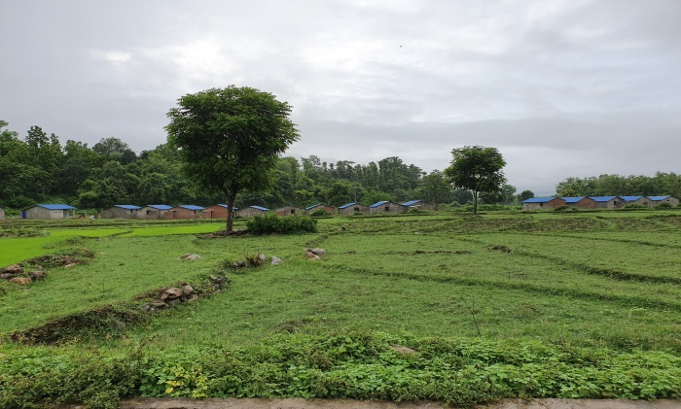 | 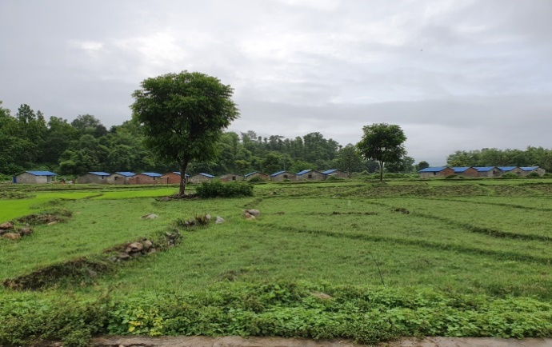
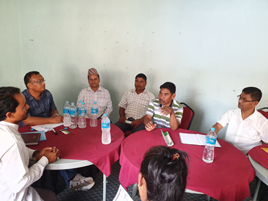 | 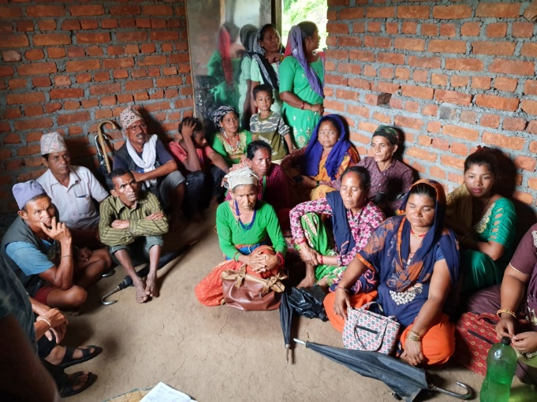
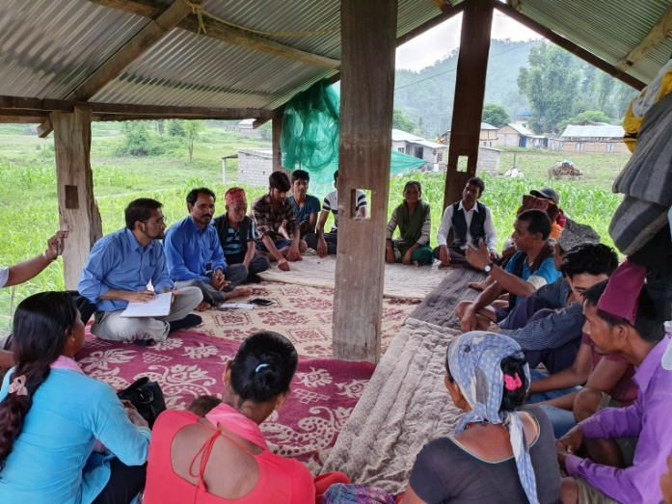 | 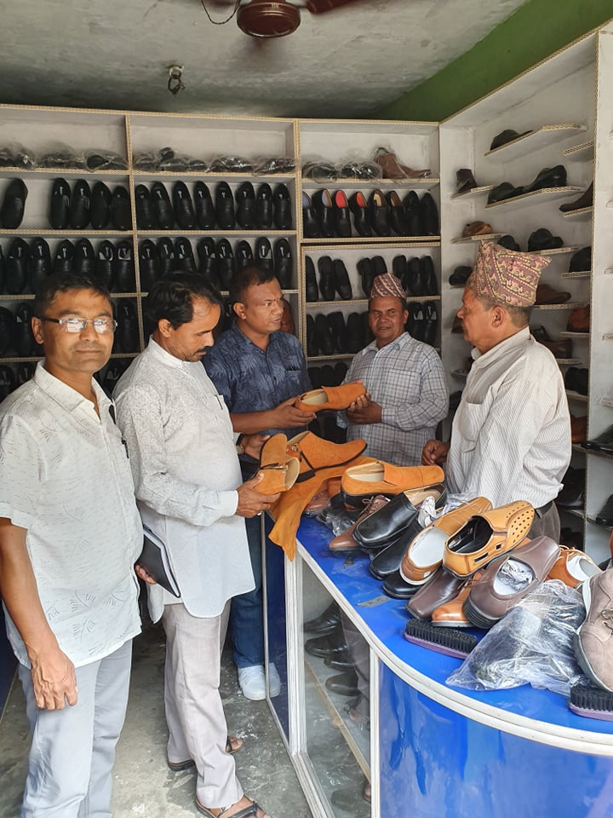

Note: The total freed-Haliya HHs include only those finally verified by the government to provide rehabilitation package by the end of FY 2018/19.
SIC= Section of Industrial Classification

