# Webinar – Good Jobs Change Lives: Helping Disabled Workers Get Ahead

Thursday, October 24, 2024

2:00 – 3:15 p.m. ET

## Assistant Secretary Taryn Mackenzie Williams

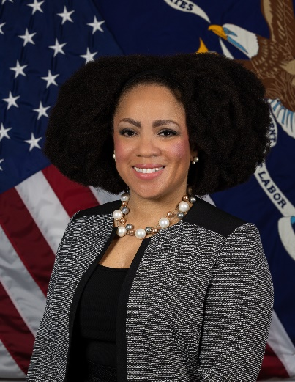

**Assistant Secretary**

**Office of Disability Employment Policy (ODEP)**

**U.S. Department of Labor**

### Biography

Taryn Mackenzie Williams is the Assistant Secretary of Labor for Disability Employment Policy. In this position, she advises the Secretary of Labor on how the U.S. Department of Labor’s policies and programs impact the employment of people with disabilities and leads the Office of Disability Employment Policy (ODEP), which works with employers and all levels of government to promote evidence-based policy that improves employment opportunities and outcomes for people with disabilities.

Previously, Taryn was the managing director for the Poverty to Prosperity Program at American Progress, which works on progressive policies focused on a broad range of anti-poverty strategies. Before joining American Progress, she worked at ODEP on a variety of issues related to education, workforce policy, Social Security, Medicaid, and civil rights. In her role as director of youth policy, Taryn led agency efforts to coordinate education and employment policy in support of improved labor force outcomes for disabled youth.

From 2014 through 2016, Taryn served as ODEP’s chief of staff. She also undertook detail assignments as associate director for public engagement and liaison to the disability community at the White House from 2014 through 2015 and as a policy adviser on the U.S. Senate Committee on Health, Education, Labor, and Pensions from 2012 through 2013.

Before joining the federal government, Taryn worked as the research coordinator for leadership programs at the Institute for Educational Leadership and as the director of programs at the National Association of Urban Debate Leagues headquartered in Chicago. She holds a bachelor’s degree in public policy from Brown University and a master’s degree in education with a concentration in administration, planning, and social policy from Harvard University. She resides in Washington, DC.

## Emlyn Bottomley – Presenter

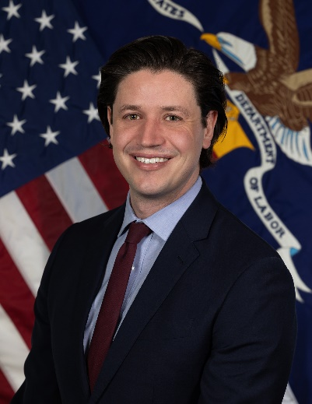

**Policy Analyst, Good Jobs Initiative**

**U.S. Department of Labor**

### Biography

Emlyn Bottomley is a Policy Analyst at the U.S. Department of Labor’s Good Jobs Initiative, where he helps coordinate cross-government efforts to promote equitable and high-quality jobs in federal investments. Before joining the Good Jobs Initiative, he was a workforce analyst in the Employment and Training Administration’s Office of Policy Development and Research with a portfolio that included data analytics and strategic planning. Prior to joining the federal government, he worked at the UC Berkeley Labor Center researching the ways emerging technologies such as surveillance, algorithmic management, and automation impact the workplace. He has a master’s degree in public policy from the University of California, Berkeley.

## Louis (Lou) Orslene – Moderator

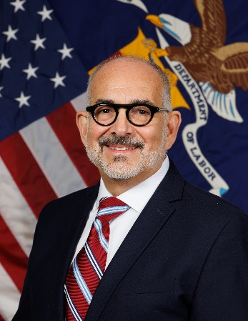

**Director, Employer and Workplace Policy**

**Office of Disability Employment Policy (ODEP)**

**U.S. Department of Labor**

### Biography

Louis Orslene, MPIA, MSW, serves the Office of Disability Employment Policy, U.S. Department of Labor, as the Director for the Employer and Workplace Policy Team. The Employer Team examines the policy issues and barriers facing employers as they seek to recruit, hire, retain, and advance individuals with disabilities in the workplace. The Team fulfills its mission by encouraging the adoption of disability-inclusive employment policies and practices that meet the needs of private and public employers and people with disabilities.

Before joining ODEP, Lou was a Disability Policy Advisor supporting the Department of Defense Office of Diversity, Equity, and Inclusion. Lou has also been the Co-Director of the Department of Labor’s Job Accommodation Network (JAN). Lou graduated from the University of Pittsburgh with master’s degrees in public and international affairs and social work. Lou also holds a certification in disability management as well as a Certificate in Managing Public and Non-profit Organizations. He has an undergraduate degree in Human Resource Management.

# 

## M.L. (Mike) Efaw – Panelist



**National Legislative Director**

**Brotherhood of Railroad Signalmen**

### Biography

M.L. (Mike) Efaw has a career spanning more than 30 years in the railroad industry, with nearly two decades in the field at CSX Transportation Railroad. Mike has held significant leadership positions at every level in the union. Since February 2019, he has been serving as the national legislative director for the Brotherhood of Railroad Signalmen. In early 2018, he was diagnosed with multiple sclerosis after having spent years experiencing the various symptoms of the autoimmune disease. He is happily married to Valerie, his wife of more than 33 years. Together, they have four children and two grandchildren.

## Anupa I. Geevarghese – Panelist

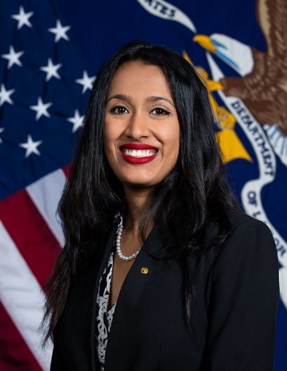

**Deputy Director**

**Office of Federal Contract Compliance Programs (OFCCP)**

**U.S. Department of Labor**

### Biography

Anupa Iyer Geevarghese serves as the noncareer Deputy Director for the U.S. Department Labor’s Office of Federal Contract Compliance Programs (OFCCP). Anupa previously served as the chief of staff for the Office of Disability Employment Policy (ODEP). As chief of staff, she collaborated closely with ODEP’s Assistant Secretary and other U.S. Department of Labor leaders to identify and implement strategies for increasing the number and quality of employment opportunities for people with disabilities.

Anupa came to the Labor Department from the U.S. Department of Defense, where she served as a subject matter expert and senior disability policy advisor for diversity, equity, inclusion, and accessibility initiatives. Prior to that, she worked for seven years at the Equal Employment Opportunity Commission (EEOC), where she was instrumental in implementing updates strengthening Section 501 of the Rehabilitation Act of 1973. Before beginning federal service, she worked for various nonprofit advocacy organizations, including the Mental Disability Advocacy Center, and served as a union organizer for the Service Employees International Union. Anupa holds a JD from Seattle University School of Law and a BA in political science from the University of California, Los Angeles.

## Maya Goodwin – Panelist

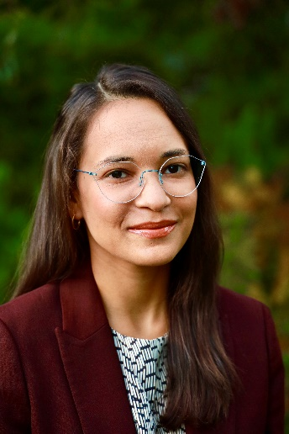

**Workforce Strategy Lead, Office of Energy Jobs**

**U.S. Department of Energy**

### Biography

Maya Goodwin serves as the Workforce Strategy Lead in the Office of Energy Jobs at the U.S. Department of Energy. In this role, Maya advances a focus on effective, inclusive workforce strategies across the Department’s activities, investments, and messages. This work comes at a critical time: As the nation shifts to a net zero-emissions economy, the Department’s investments are propelling large-scale change in the energy sector—changes that create an urgent opportunity to boost strategies that help to effectively attract, train, and retain skilled workers.

An economic policy strategist and researcher, Maya has deep knowledge of workforce development, labor, and economic mobility policy. Maya has worked to advance worker-focused, inclusive economic policy strategies in several roles: as a senior manager for workforce policy and research at the Markle Foundation, a social impact and economic policy consultant with Sperling Economic Strategies, a fiscal policy researcher at the Pew Charitable Trusts, and a workforce development researcher at the Aspen Institute’s Economic Opportunities Program.

Maya holds master’s degrees from Sciences Po and the London School of Economics. She earned her bachelor's degree in anthropology, with a focus on political and economic anthropology, from Princeton University.

## Karen R. Owens – Panelist

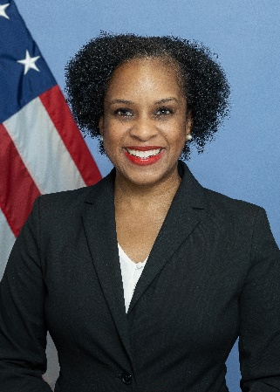

**Senior Policy Advisor**

**CHIPS for America**

**U.S. Department of Commerce**

### Biography

Karen Renae Owens is an innovative critical thinker and problem solver with 25 years of leadership experience within the public policy, private, and nonprofit sectors. She is a results-oriented and adaptable senior leader with more than 10 years of direct team supervisory and data analysis experience. An enthusiastic and ethical executive, Karen specializes in stakeholder engagement, efficient operations, monitoring and evaluation, and effective public policy program implementation in Africa, Asia, and North America.

As a federal public servant, Karen served as a district director and chief of staff for Members of Congress. Currently, as senior policy advisor for the CHIPS for America Program at the U.S. Department of Commerce, she devises and implements policy and strategic plans to inform, educate, and engage the public and key stakeholders about the CHIPS for America programmatic mission.

Born and raised in Boston, Karen is affectionately known as the “globetrotting adventurer” of her family because she has lived in five countries and 10 U.S. cities. A graduate of Howard University’s School of Business, Karen also earned a master of urban planning in economic development from New York University and a master of divinity from Duke University. She has also completed design thinking courses at the LUMA Institute in Pittsburgh. Currently, Karen serves as a Harvard University fellow with an appointment at Harvard Divinity School.

## Paige Shevlin – Panelist



**Strategic Advisor for Infrastructure Workforce Development**

**Office of the Secretary**

**U.S. Department of Transportation**

### Biography

Paige Shevlin is the Strategic Advisor for Infrastructure Workforce Development at the U.S. Department of Transportation. In that role, she is responsible for implementing the Bipartisan Infrastructure Law in a way that promotes high-quality jobs and greater diversity in the infrastructure workforce. Paige has extensive experience in federal and local government with a focus on job training, higher education, and social insurance programs.

As the economic development policy advisor to the King County Executive in Washington State, Paige was responsible for working with regional organizations to create economic and workforce development strategies for the county. Before joining local government, Paige served in the Obama administration as special assistant to the president for economic policy at the White House National Economic Council. She was responsible for leading the development of labor market policies, including the Vice President’s Job-Driven Training initiative and policy decisions relating to regulations of the Workforce Innovation and Opportunity Act. Paige also held appointed positions at the Council of Economic Advisers and the U.S. Department of Labor.

Prior to joining the Obama administration, she was the assistant policy director at the Hamilton Project at the Brookings Institution and an assistant analyst at the Congressional Budget Office. Paige received a BA in economics from Wellesley College and an MA in public affairs from Princeton University.