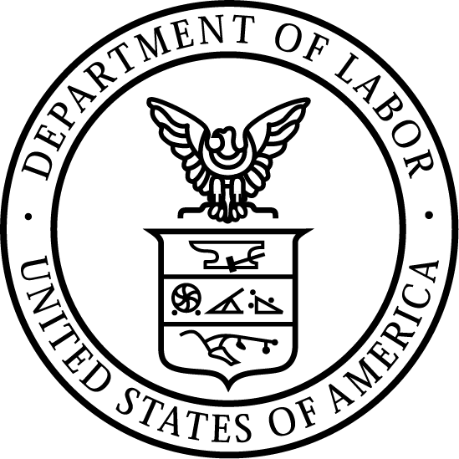
News Release
U.S. Department of Labor | June 5, 2024

US Department of Labor announces 2024 Iqbal Masih Award winners, recipients in Egypt, Ghana lauded for contributions to end child labor
Wadi El Nil Association, Andrews Addoquaye Tagoe

WASHINGTON – The U.S. Department of Labor today announced the recipients of the 2024 Iqbal Masih Award for the Elimination of Child Labor, presented annually to recognize exceptional efforts by an individual, company, organization or national government to end the worst forms of child labor

The recipients are an Egyptian civil society organization, Wadi El Nil Association and a trade union leader in Ghana, Andrews Addoquaye Tagoe.

“The recipients of the 2024 Iqbal Masih Award are champions in the fight against child labor,” said Deputy Undersecretary for International Affairs Thea Lee. “Their unwavering efforts and achievements in the ongoing campaign to eliminate child labor have rescued children from the dangers of hazardous work and created economic opportunities for families to help derail the cycle of child labor in Egypt and Ghana.”

A pivotal force in combating child labor in Egypt’s limestone mining sector for more than two decades, Wadi El Nil Association rescues children from hazardous quarries, offering them pathways to education and skills development. The association seeks to break the connection between poverty and the cycle of child labor by providing microloans to families to help them achieve economic stability. In recent years, Wadi El Nil has extended additional support to vulnerable families and collaborated with community organizations and volunteers to reduce the impact that the pandemic had on families in need.

As Deputy General Secretary of the General Agricultural Workers Union of the Ghana Trade Union Congress, Tagoe has played a significant role in advancing child and workers’ rights and is a powerful force in the country’s efforts to end child labor in the agricultural industry. By organizing and formalizing the agricultural economy in rural areas and working with communities to eliminate child labor, Tagoe has helped thousands of children move from child labor into school. His passionate and effective advocacy has helped to create a strong network of anti-child labor champions in Ghana and beyond.

A non-monetary award established in 2008 by Congress, the Iqbal Masih Award for the Elimination of Child Labor is presented each year by the Secretary of Labor. The award honors its namesake, a Pakistani child sold into slavery at age four to work as a carpet weaver. After escaping at age 10, Masih became an outspoken public advocate against child exploitation. Two years later, in his native Pakistan, he was killed tragically. Iqbal Masih was 12 years old.

Learn more about this year’s winners and past recipients.

Learn more about the department’s international work.

# # #
Media Contacts:
Christine Feroli, 301-793-3023, feroli.christine.e@dol.gov
Ryan Honick, 202-693-4247, honick.ryan.l@dol.gov
Release Number: 24-1055-NAT

