Photo annex: discussions with religious authorities

Roundtable discussions for religious authorities (Activity 1.1.3.2.1)
The first roundtable took place on March 5th, 2018, on the eve of the National Day against Slavery, in Selibaby, Guidimakha region.
Fifty eight religious leaders (58) were registered at the event.

Speakers:
- President of the Special Criminal Court of Nema, Judge Aliou Ba
- Professor Yayha Ould Bara, Professor at the University of Nouakchott
- M. Ahmed Lemrabott, former regional delegate of the Ministry of Islamic Affairs
- M. Mohamed Benejara, president NGO ADIG

ILO delegation:
- Jean Marie Kagabo, ILO Fundamentals, Geneva
- Marc Niñerola, NPC Bridge Mauritania
- Aly Bamby Diabira, Assistant Bridge Mauritania

Participants:
See monitoring form.
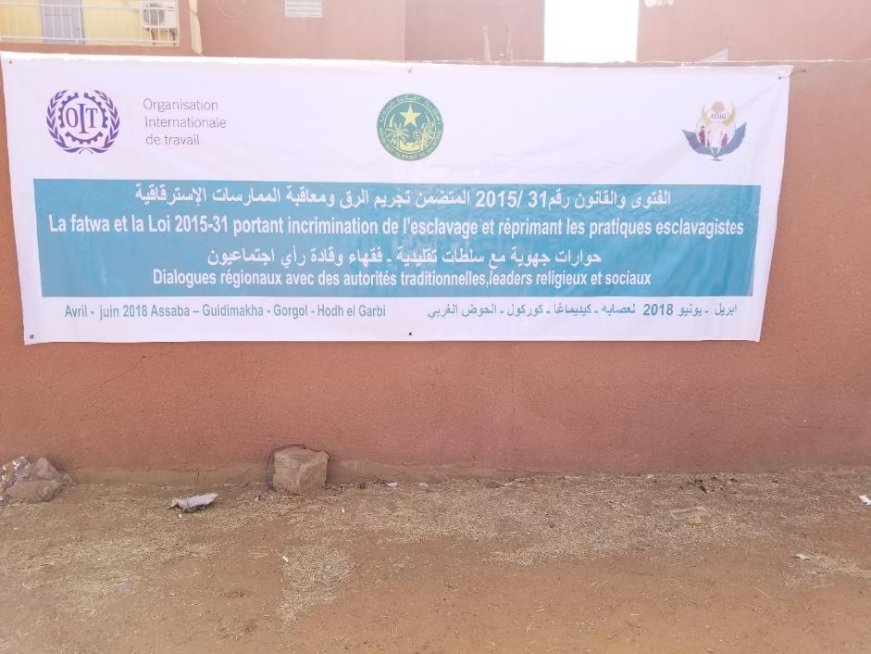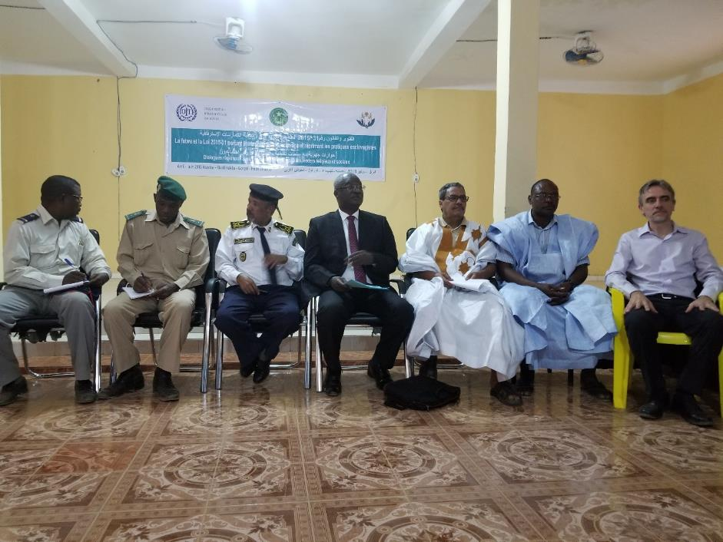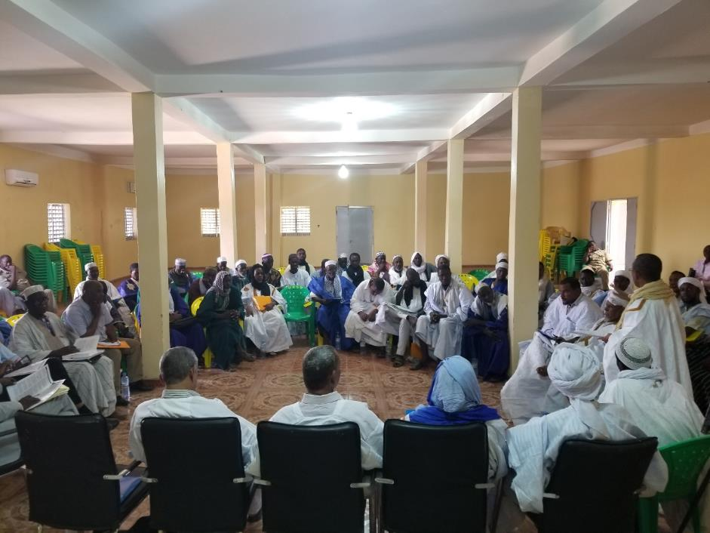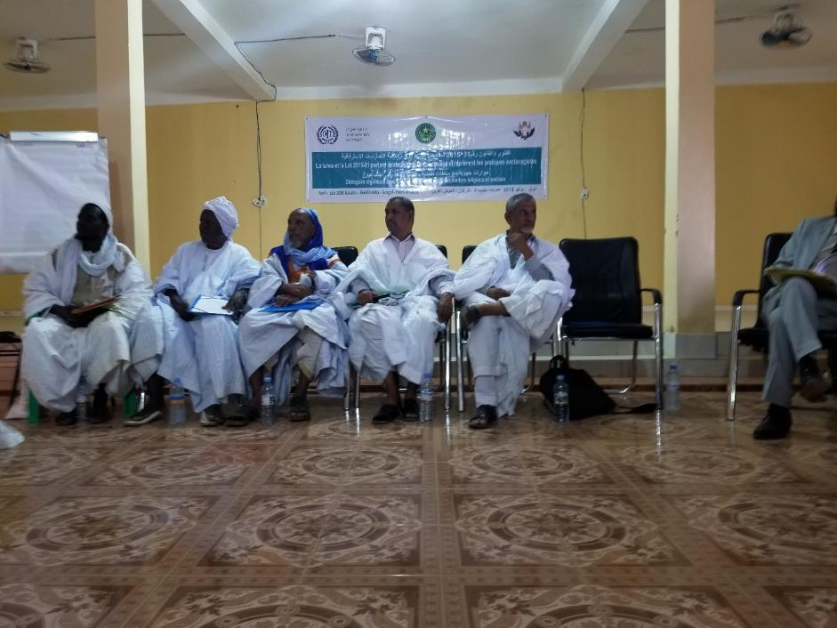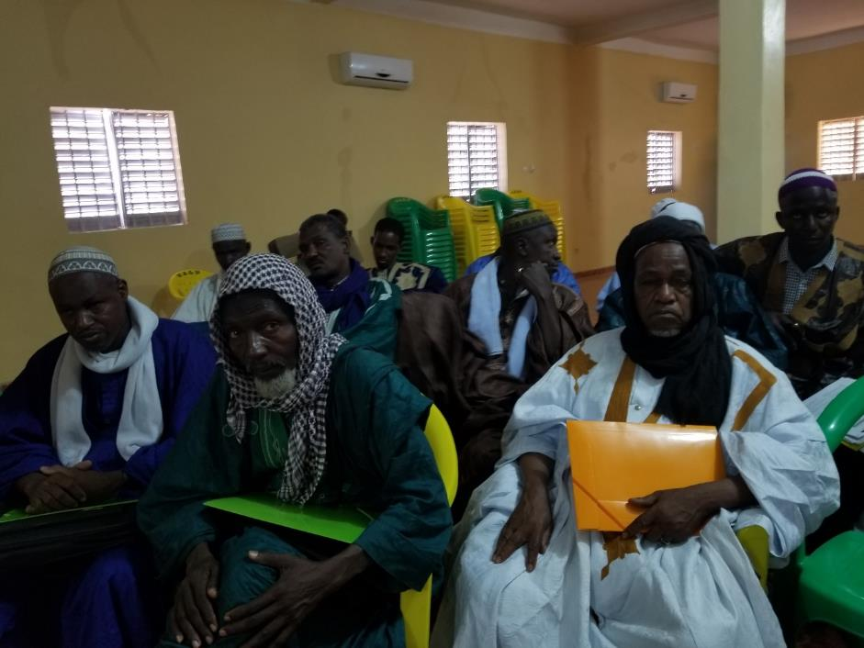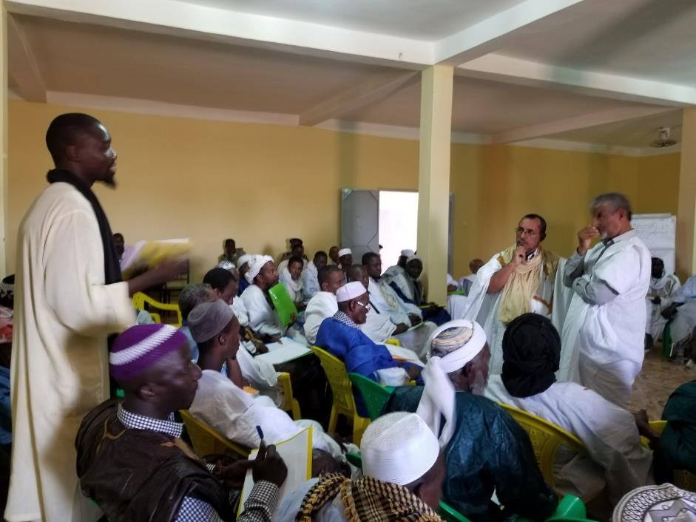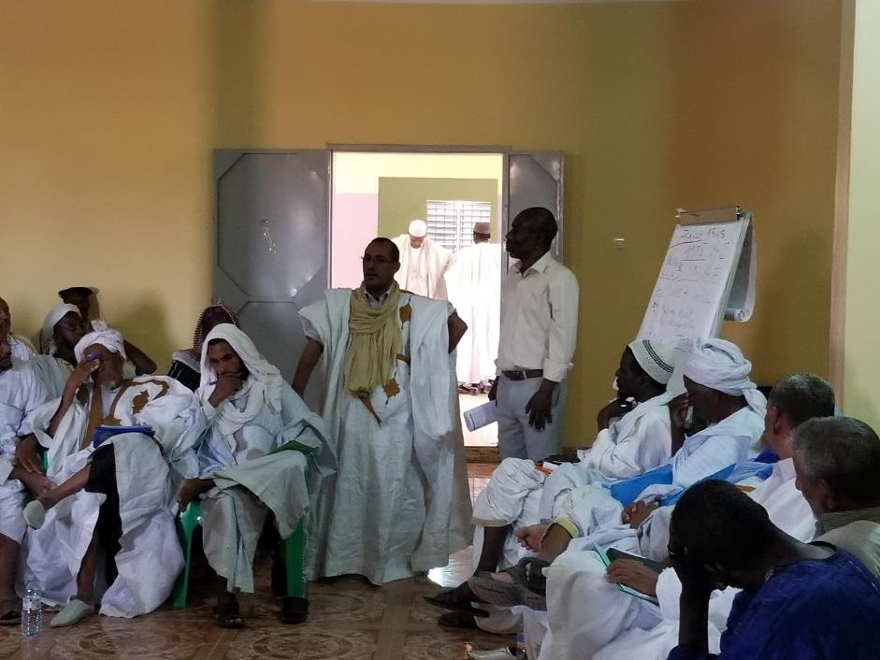

The roundtable in the media: https://www.chezvlane.com/Les-imams-du-Guidimakha-a-l-ecole-de-la-loi-et-de-la-fatwa-sur-l-esclavage_a6536.html

