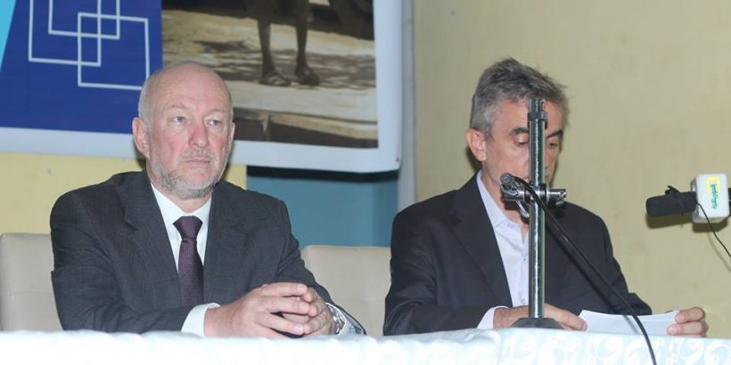

Bridge NPC opening speech at the International day against child labour, Nouakchott, 12 June 2017
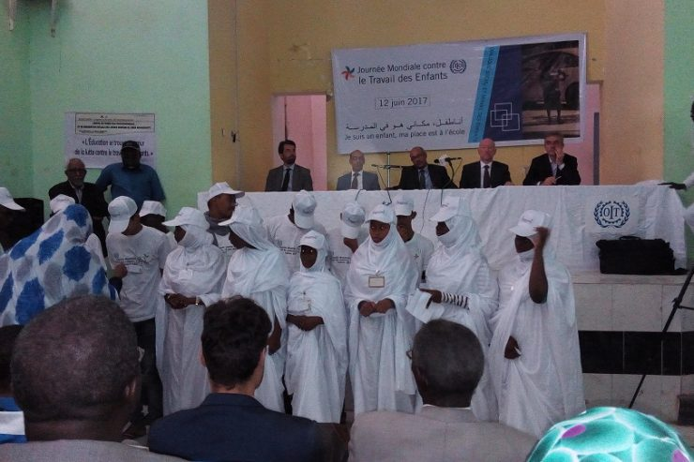
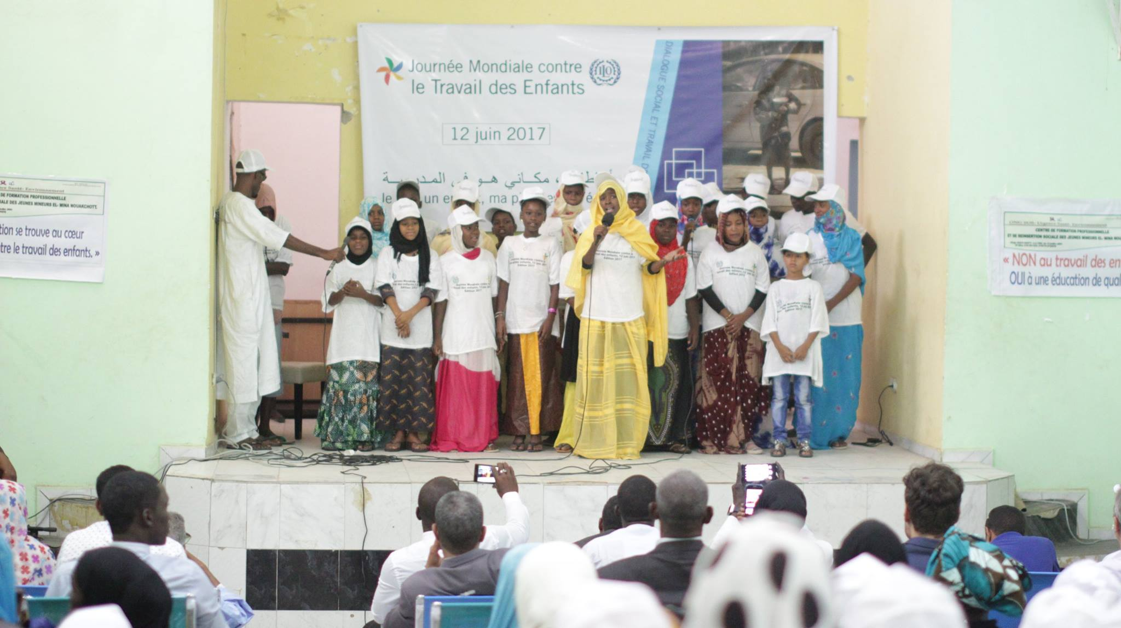
Left: Mario Samaja, United Nations Resident Coordinator in Mauritania

Center: Secretary General of the Ministry of Labour Left: EU Deputy Representative in Mauritania

