**Times of Day**

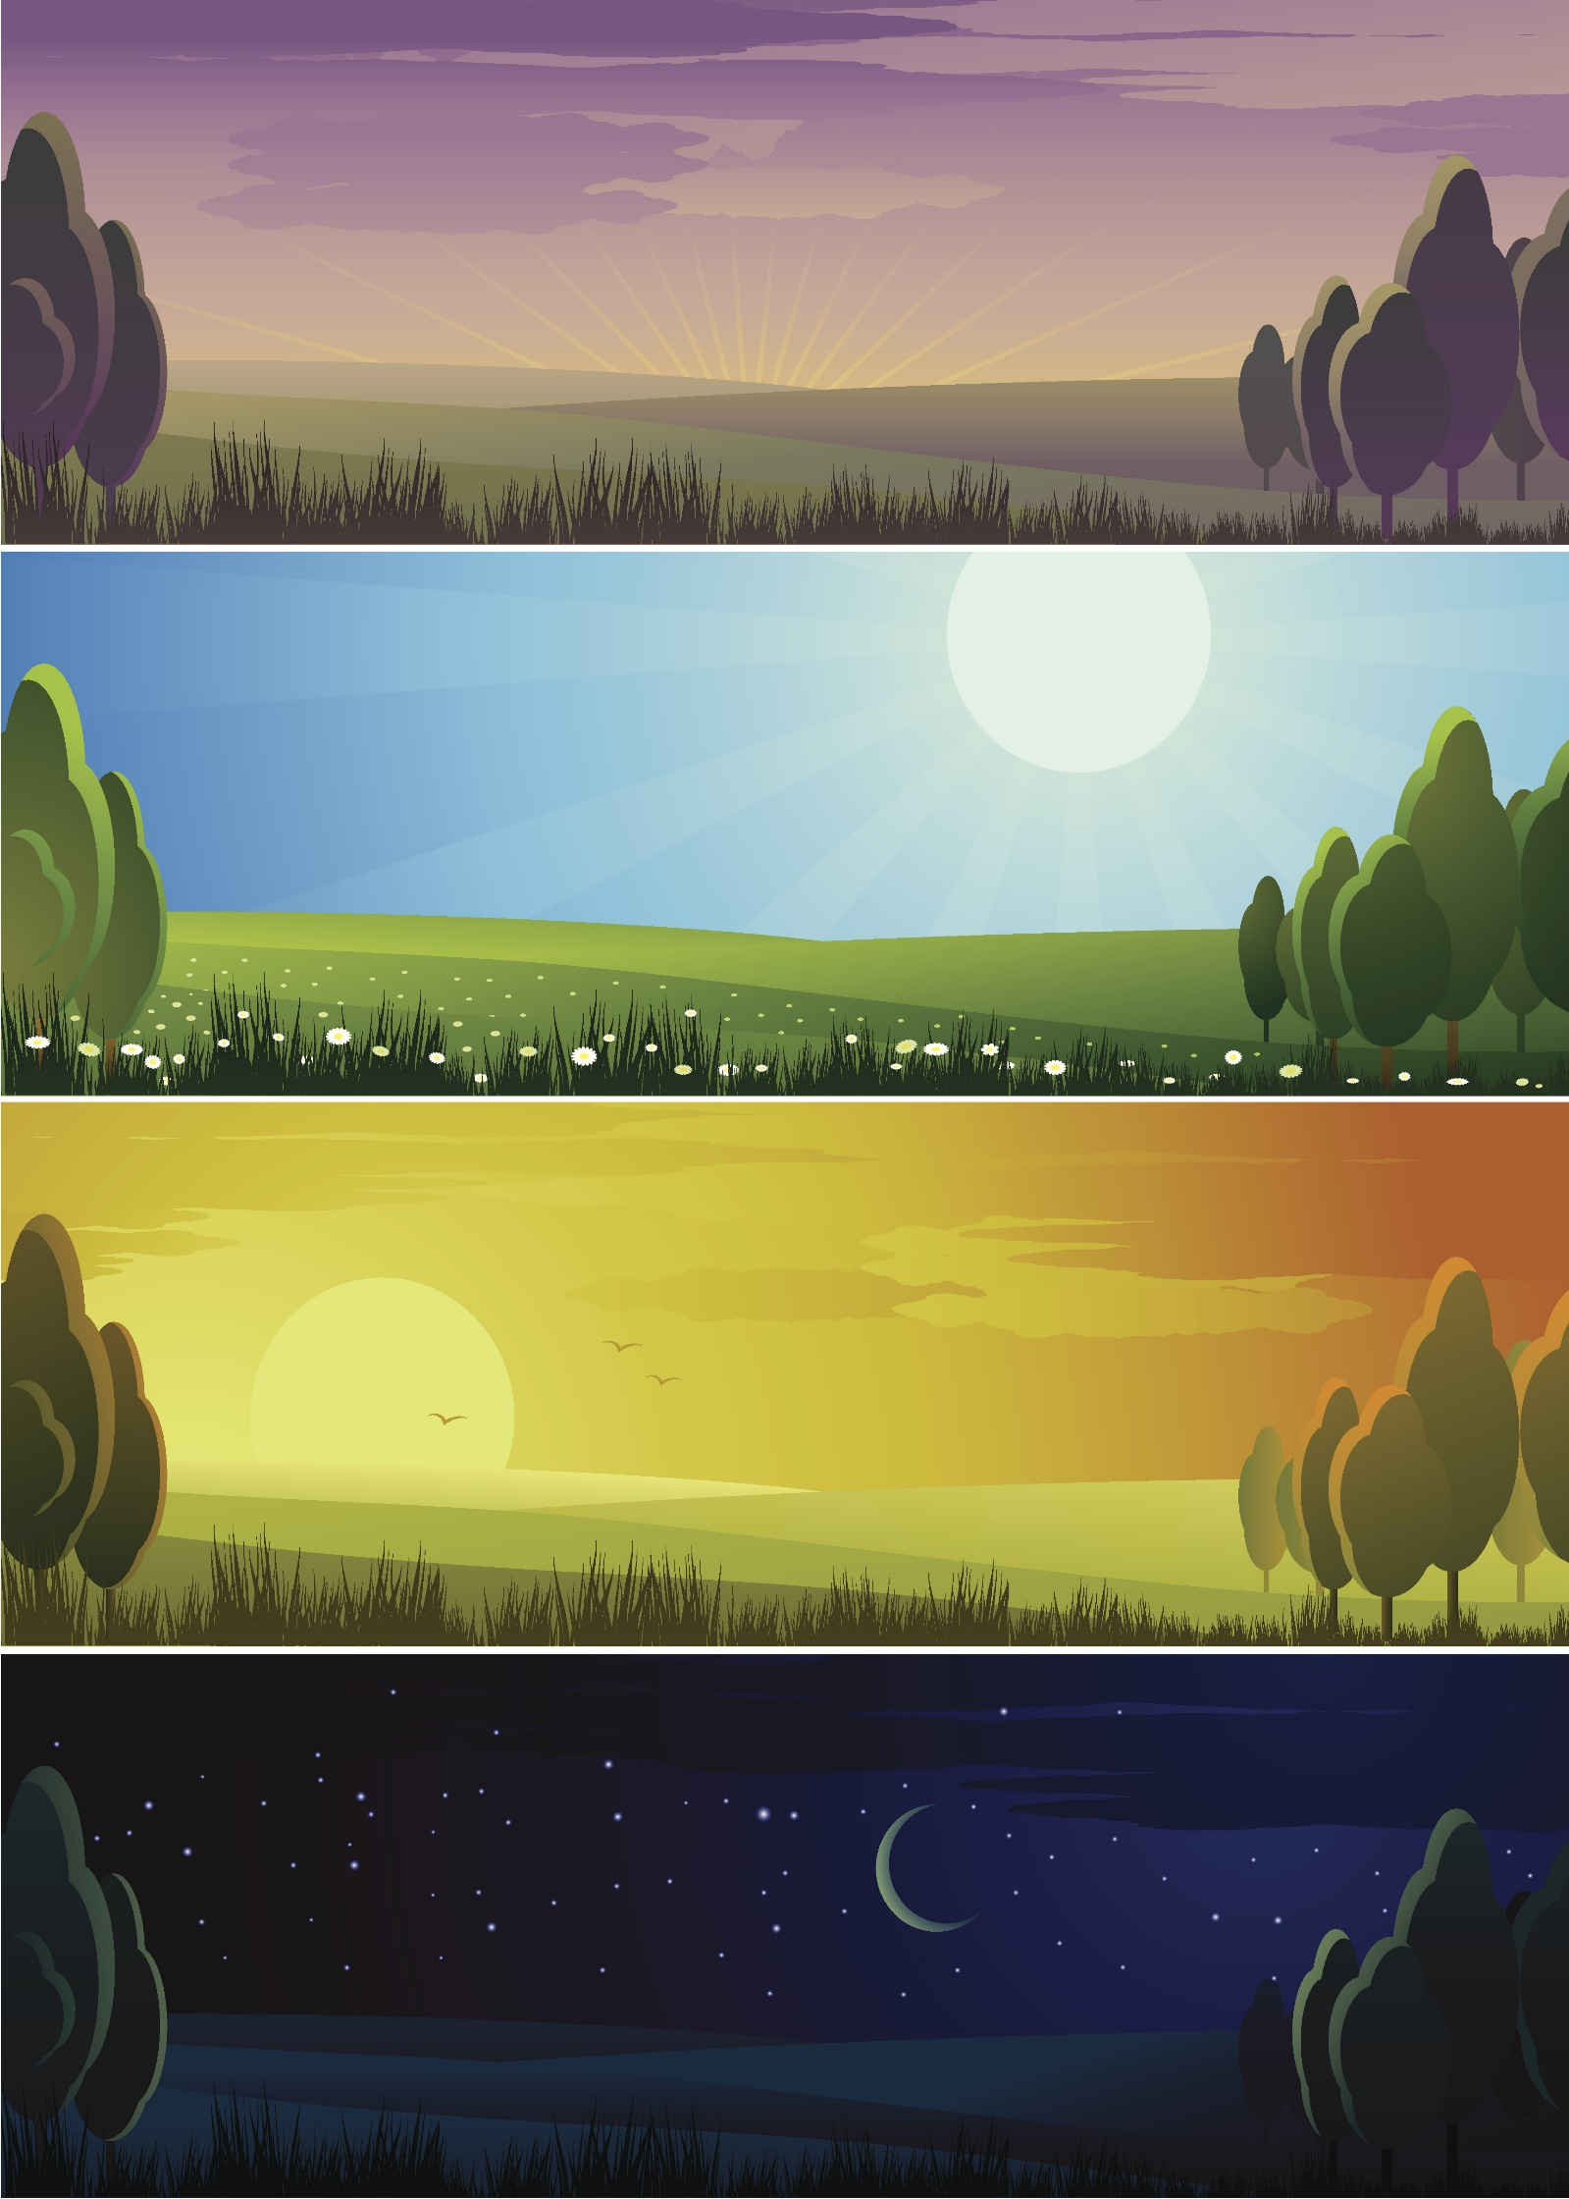

**Sunrise**

**Night**

**Sunset**

**Day**